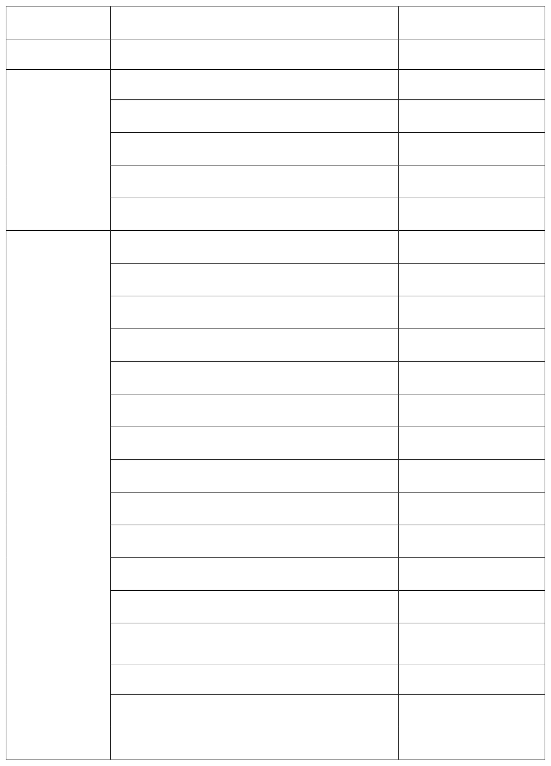
CHAPTER NO
TITLE | PAGE NO
LIST OF TABLES & CHART  INDRODUCTION | 5
Need For The Study | 7
Scope And Signification Of The Study | 7
Objective Of The Study | 7
Statement Of The Problem | 8
CHAPTER 2 | 14-18
RESEARCH METHODOLOGY | 9
2,1 Research Methodology | 10
2.2research Design | 10
2.2.1 Descripitive Research Design | 10
2.3sample Technique | 11
2.3.1 Non Profitablility Sampling | 11
2.3.2 Convenience Sampling | 11
2 .4 Sample Size | 11
2.5source Of Data | 11

1

3

2
TABLE OF CONTENT

2.6 Structure Of The Questionnaire
2.7 Analytical Tool

CHAPTER-3
  - Company Profile
  - Land Mark Group

  - Founders
11

12

18-30

13
16
17

1

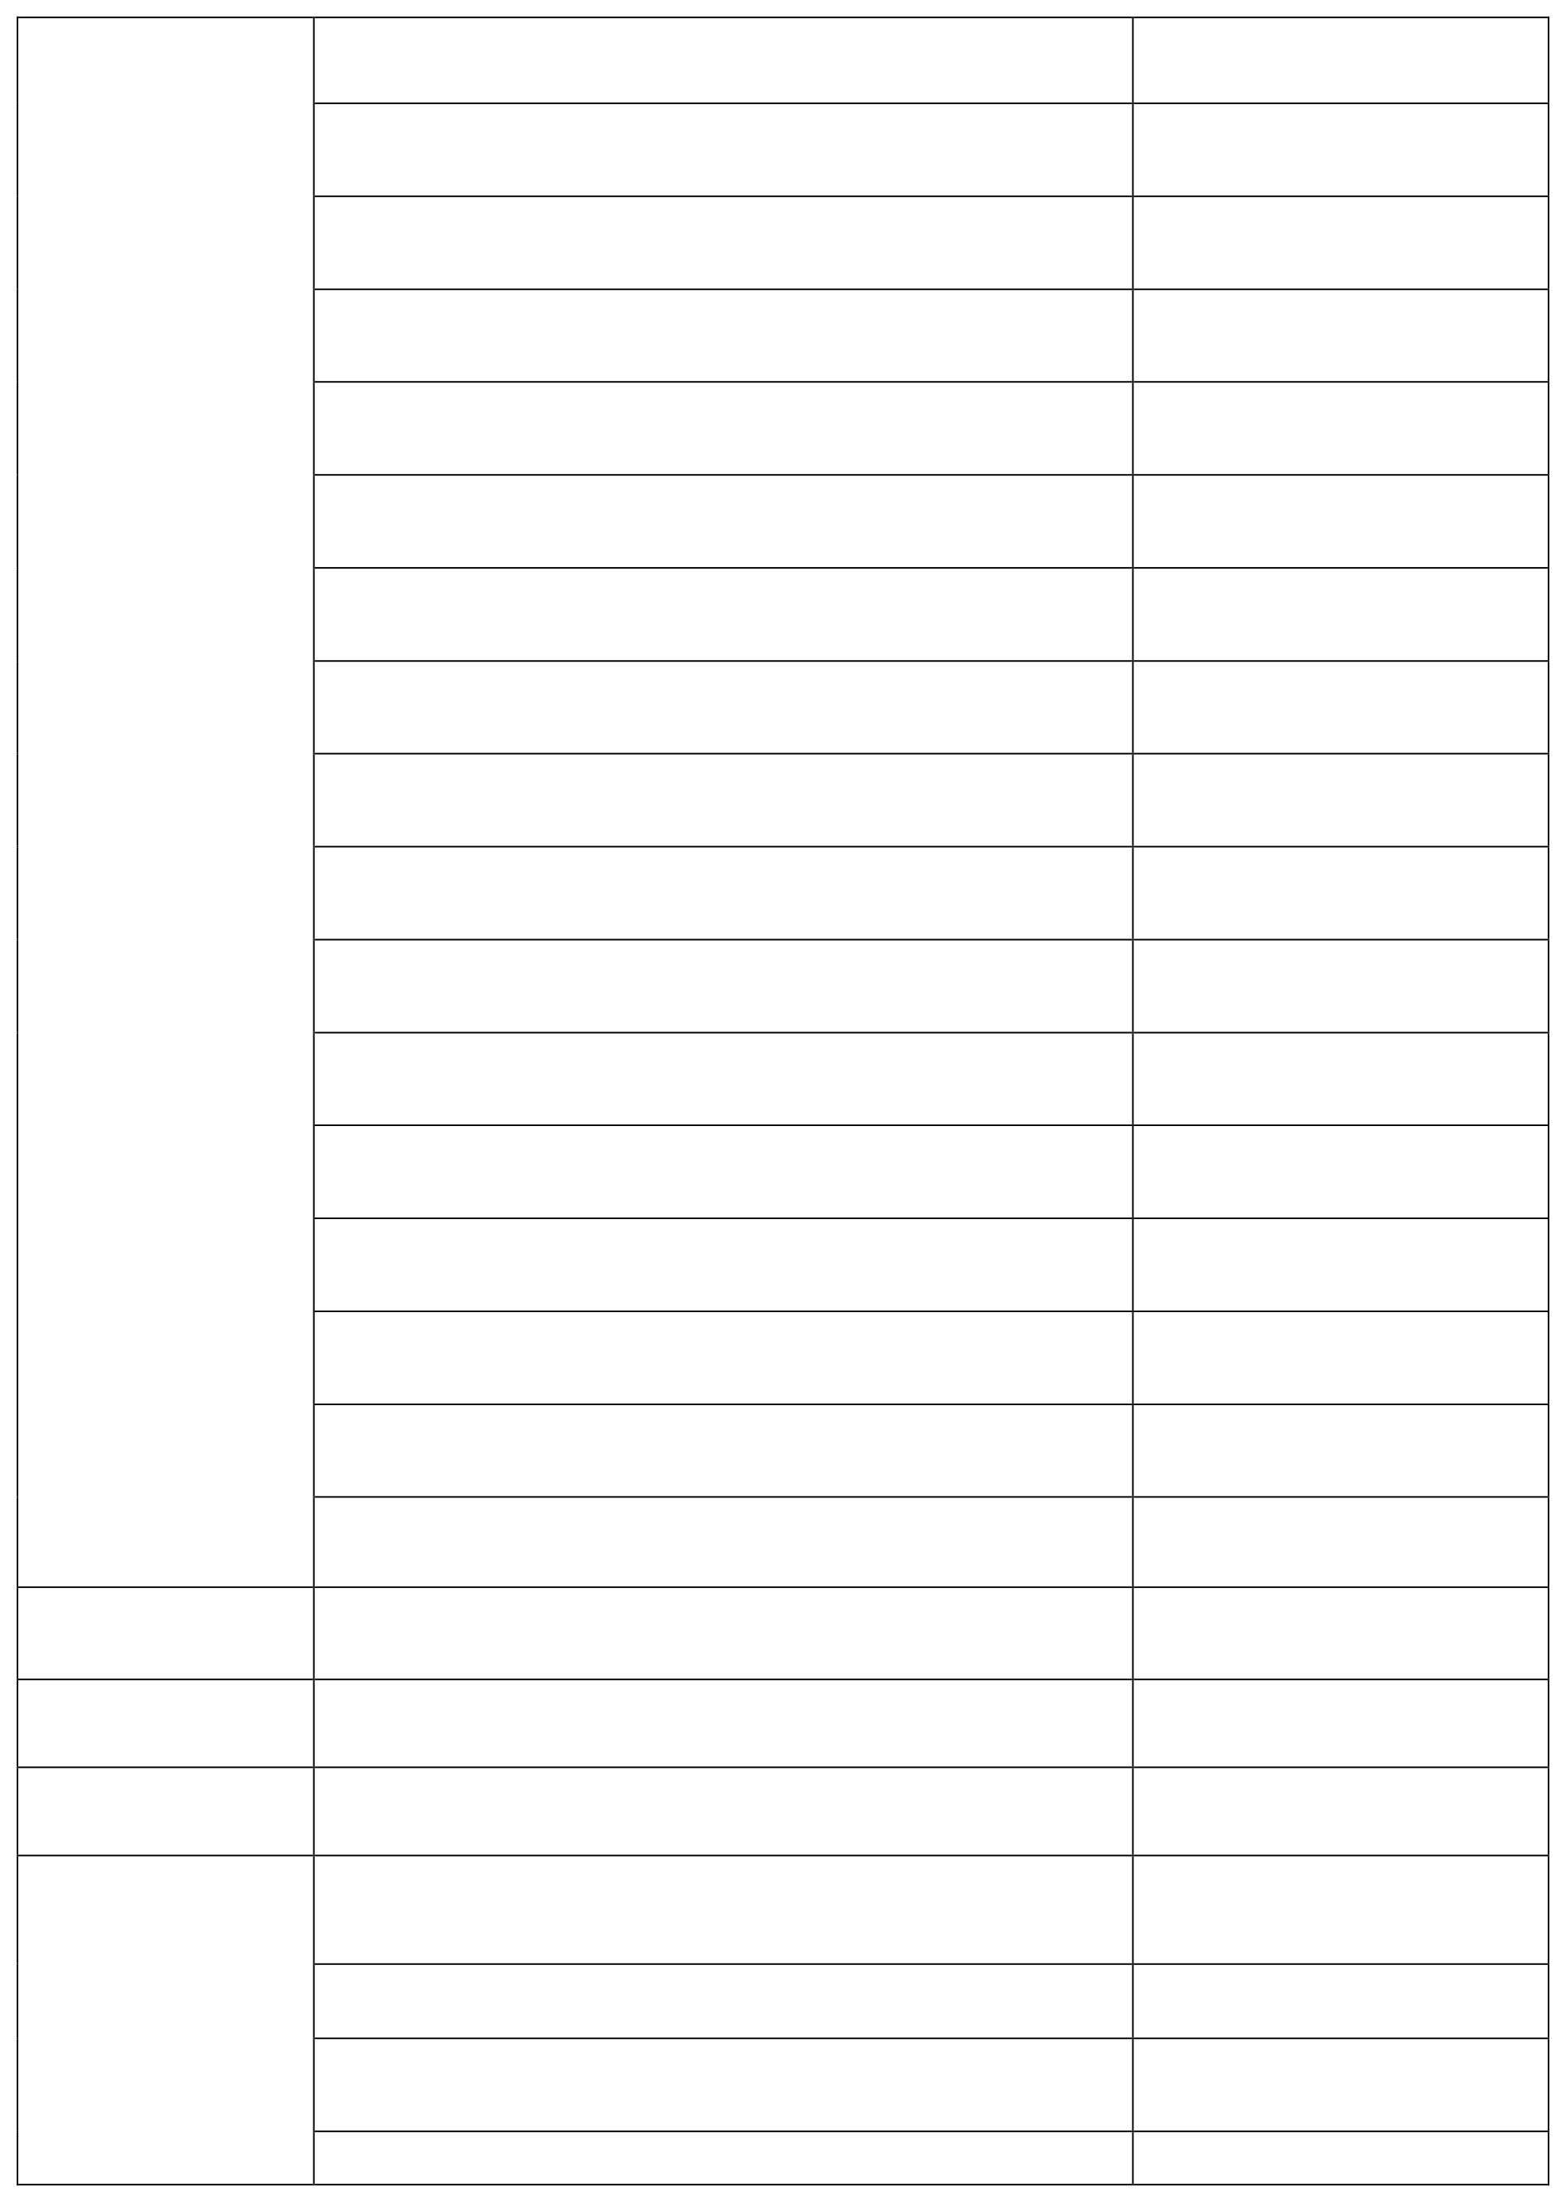
  - Landmark Group's Renowned Retail Brands

  - PRODUCT RANGE

    - Categories Of Apparel

    - Footwear And Accessories

    - Seasonal Collections

    - Special Collaborations

  - SUPPLY CHAIN AND OPERATIONS

    - Manufacturing Process

    - Logistics And Distributions

    - Retail Stores Operations

    - E- Commerce And Online presence
3
  - COMPETITIVE ANALYSIS

    - Major Competitors In The Market

    - Comparison Of Pricing Strategies

    - Market Share Analysis

3.7.5 Swot Analysis

Factor Influencing Customers Satisfaction

4 CHAPTER -4

Data Analysis And Interpretation
CHAPTER-5
Summary & Findings

Conclusions
REFERANCE
ANNEXURE (QUESTIONNAIRE)

2
1
7
1
8

1

8

1
8

1

8

1
8

1

9

1
9

1
25
9
26-45
2
0
46- 50
2
46
1
49
250
3

2

3

2
3
2

FIGURE  NO | PARTICULARS |  | PAGE NO
FIG 4.1 | Gender wise classification of respondents | 26
FIG 4.2 | Age wise classification of the respondents | 27
FIG 4.3 | Showing the customers frequency of the  purchase | 28

FIG 4.4

FIG 4.5

FIG 4.6

FIG 4.7

FIG 4.8

FIG 4.9

FIG 4.10

FIG 4.11

FIG 4.12

FIG 4.13

FIG 4.14

FIG 4.15

FIG 4.16

FIG 4.17
Showing the customers frequency of the 29
purchase
showing customer assistance process in max fashion shopping 30
showing customers satisfied with the billing system process 31
showing promotional services that
customers expect 32
showing customers checking Max Buddy 33
program while visiting
showing customers get any promotional 34
coupons for future purchase
showing customers ever redeemed the 35
promotional coupons
showing level of satisfaction for the Mens 36
wear
showing level of satisfaction for the Womens 36
wear
showing level of satisfaction for the Kids 38
wear
Showing level of satisfaction for the Foot 39
wear & other accessories
Showing customers preferred location 40
facilities
Showing customers preferred quality of 41
product
showing customers preferred staff service 42

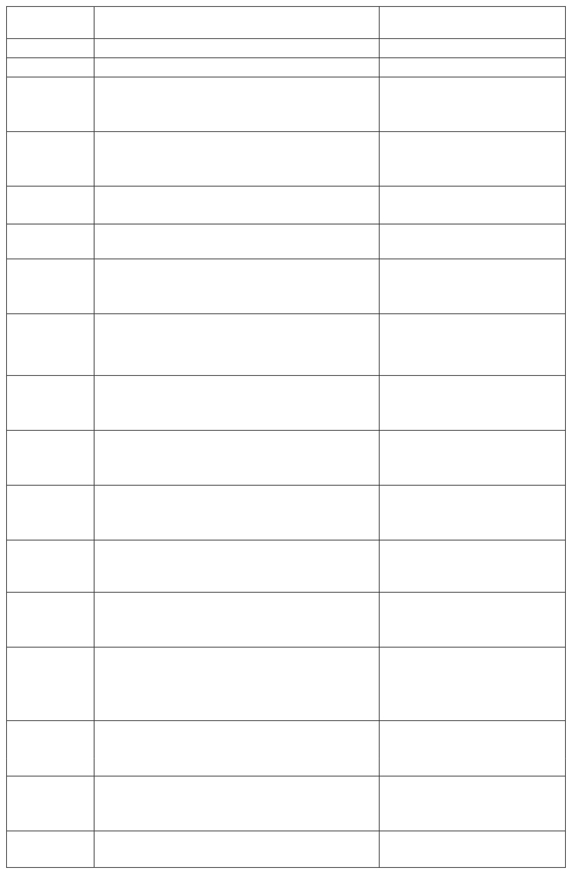
3

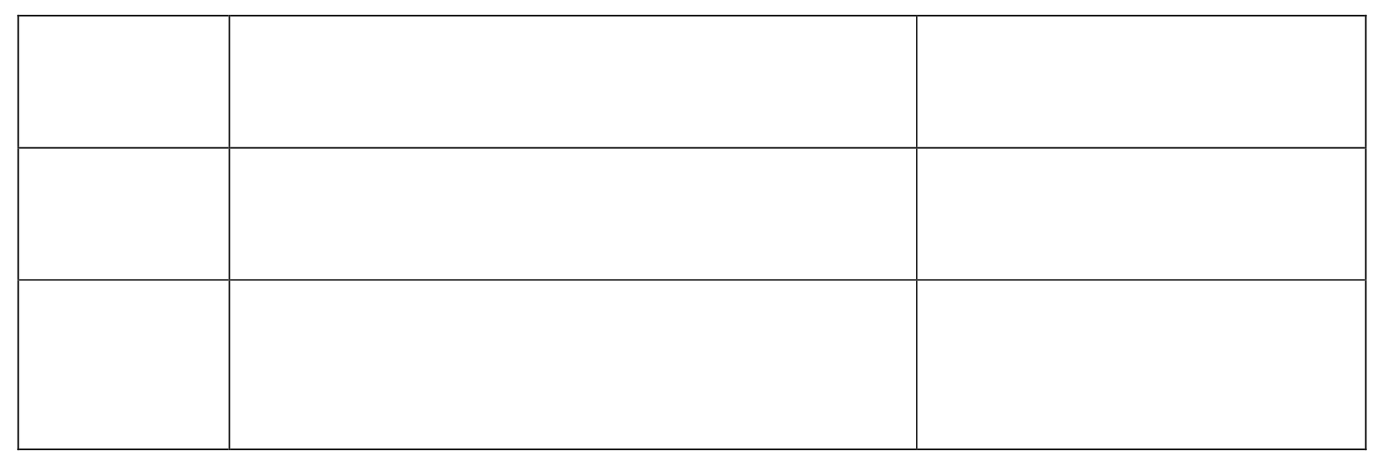
FIG 4.18
showing customers preferred variety/ range available
43
FIG 4.19
showing customers overall experience visiting at the max fashion store
44
FIG 4.20
Showing customers face any obstacles while 45
engaging with max fashion

CHAPTER – 1

Introduction

Customer preferences is used primarily to mean to select an option that has the greatest anticipated value among several options by the customer in order to satisfy his/her needs or desires. Preferences indicate choices among neutral or more valued options available. The preference of the customer is the result of their behavior they show during searching, purchasing and disposing the products. Every human being is a customer of different produces. If there is no customer, there is no business. Therefore, customer satisfaction is very important to every business person. The customer satisfaction after purchase depends on the product performance in relation to his/her expectations. Philip Kotler (2024) observed that satisfaction is a person's feelings of pressure or disappointment resulting from product's perceived performance (outcome) in relation to his or her expectations. Customer satisfaction is the level of a person's felt state resulting from comparing a product's perceived performance (outcome) in relation to the person's expectations. This satisfaction level is a function of difference between perceived performance and expectations. If the product's performance exceeds expectation, the customer is highly satisfied or delighted. If the performance matches the expectations, the customer is satisfied. If the products performance falls short of expectations, the customer is dissatisfied. Customer satisfaction or dissatisfaction is the feeling derived by the customer when he compares the product's actual performance with the performance that he expects out of it. Customers make their expectations from the service quality, service, delivery, communications, past experiences and references. These all are to be judged correctly by the management so that their perceptions match with customer expectations. If any of these factors are wrongly interpreted, then the expected level of customer satisfaction cannot be reached.

The development of shopping malls can be traced back to 1850‟s, when the first Department store was opened in Paris starting the era of mass consumption. Mass Production and consumption rationalized and industrialized shopping. The development of department stores meant major transforms in the landscape of cities.
Commercial activities moved from public streets to privately owned buildings.

Department stores changed the concept of shopping and liberated people to enjoy it.
Understanding the categories is very important because successful strategies and tactics vary from one type or retailer to the next, and knowing what kind of store is to be run
is the first step in designing the marketing programs.

A retailer is any business that sells products to customers for personal use. Retailing is the final link in the marketing channel bringing products and services from the producers and providers to customers Retailing is important because it creates
economic utility, it helps manufacturers reach customers, and it makes a significant contribution to the economy Producers rely on retailers to offer the right products at the right place.
Retailing is in the midst of tremendous change today, making it one of the most dynamic and challenging areas in marketing./ The demand for time saving services continues to grow, making services retailing one of the hottest marketing trends from the 1990‟s.
“The purpose of a business is to create customers.”

The Importance of keeping those same customers and growing the depth of their relationship with them.
Hence a customer is the most significant part of any business concern. Without a customer, there is no purpose to a business. Hence there is a direct relationship between number of customers to the profits of the concern. Large number of customers bring larger profits.
A customer is the most important visitor on our premises. He is to dependant on us we are dependent on him. He is not dependant on us, we are dependent on him. He is not an outsider on our business. He is a part of it. We are not doing a favor by serving him, he is doing us a favor by giving us an opportunity to do so.

NEED FOR THE STUDY
Need for the study is the customer satisfaction is necessary for all the business or small.
The satisfaction of the customer is an important task. No matter what type of the business operators customer are needed, customer are the vital for the success of the business.

SCOPE AND SIGNIFICANE OF THE STUDY

This study focuses on how and why customer make decisions on goods and services. Customer behavior and research goes for beyond the decision customer make about products they buy and their subsequent evaluations of this products.
Max achieved increased sales over the past years. Due to the prevailing heavy competition in the market, an effort has been made to survey the customer level of satisfaction for max. A study with consistency required to comprehend the level of customer preference and satisfaction level. The survey depends on the preference and satisfaction of the respondents. In today’s world rapidly changing technology customer’s taste and preference are also characterized by rapid changes. To meet this challenging environment, a firm must be constantly innovating needs and wants. Customers taste and preference provides invaluable items and guidelines for new technologies. Keeping in mind the conveniences of the customer’s, the company offer facilities, which in turn bring the customers to their doorsteps. Based on the customer response, suitable modifications can be carried out to increase the Market share as well as companies retail shop profit.

OBJECTIVES OF THE STUDY
- To study the shopping habits of the customers.
- To study the reasons for preferring Max.
- To measure the level of customer satisfaction. To make suggestions based on the findings.

STATEMENT OF THE PROBLEM
The title of the project is “as study on customer satisfaction towards max” The aim of the organisation is to give good quality products to the customers and maintaining good relation with them. The quality of products at max is found good compare to other players. It wants to increase its market share by retaining its loyal customers and attracting new one.
The information generated by the study will help in making better decisions. The study attempts to determine the various factors and levels of satisfaction of the customers.
Now days, new organisations are coming to the business line, so the competitions among these companies tend to be more complicated. Hence the necessity of information becomes more essential for the companies decision-making to cope with the market changes.
To frame effective marketing strategies, max should have better knowledge of the market environment, since the customer satisfaction plays a vital role in the maket

CHAPTER – 2

Research Methodology

Research Methodology
Research methods are the techniques and tools by which you research a subject or a topic. Research methodology involves the learning of various techniques to conduct research and acquiring knowledge to perform tests, experiments, surveys, and critical analysis.

Research methodology simply refers to the practical “how” of any given piece of research. It’s about how a researcher systematically designs a study to ensure valid and reliable results that address the research aims and objectives.

Research Design

A research design is the arrangement of conditions for collection and analysis of data in a manner that aims to combine relevance to the research purpose with economy in procedure. This Research design applied for the study is ‘Descriptive Research.

Descriptive Research Design

Descriptive research aims to accurately and systematically describe a population, situation or phenomenon. It can answer what, where, when and how questions, but not why questions. A descriptive research design can use a wide variety of research methods to investigate one or more variables.

Sampling Technique
Sampledesign is thetheoretical basis and the practice mean by generalizing from characteristics of relatively few of the comprising population. It is the method by which the sample is chosen.

Non Profitability Sampling

Non-probability sampling is defined as a sampling technique in which the researcher selects samples based on the subjective judgment of the researcher rather than random selection

Convenience Sampling

A convenience sample is a type of non-probability sampling method where the sample is taken from a group of people easy to contact or to reach.

Sampling Technique Adopted
Convenience Sampling.

Sample Size

A sample of 100 respondents was taken as sample respondents for the purpose of study. The respondents were selected at random.

Sample Targeted People

My survey targeted people is both Men and Women at the age group of [18-60]

Sources Of Data

Collection of facts and figures about a phenomenon is one of the most important steps for any study whether it is related to business, management economic or natural sciences. Collection of data refers to systematic recording of results either by counting or by enumeration. The entire structure of statistical analysis for any enquiry is based on systematic collection of data. Broadly speaking there are two types of data.
- Primary Data
- Secondary Data

Secondary data consist of information that already consists; some were having been collected for another product.

    - Primary data
Amixof questionnaire and direct interview method was used as a tool for gathered primary data.
      - Direct personal interview
      - Indirect personal
      - Mailed questionnaire method

Advantages Of Primary Data
      - Provides highly accurate and reliable data.
      - It makes available to investigators supplementary information, which helps in
the interpretation of results.

Secondary Data
Secondary Data is form of compilation of existing or already published data. The collection of Secondary Data the money and time is relatively less cost. Keeping in mind purpose for which it is collected where as Secondary Data May or may not suit the purpose usually collects primary Data. Secondary data was collected from external sources like Websites, Journals etc.

Structure Of The Questionnaire

The questionnaire follows a simple and basic layout. It is made easy for the participants to respond to the questionnaire without any delay or confusion. The set of question and the answer options present in the questionnaire are predetermined and are constructed by myself based on general questions regarding the main topic. The structure of
questionnaire used in this project is as follows.

    - Basic introduction

The questionnaire begins with small and simplifies description regarding the questionnaire – Title and description of the topic

Personal details

The actual questionnaire begins here where the participants are asked about their personal details such as their name, age, gender and occupation.

Research related questions

The next set of questions in the questionnaire consists of the questions related to public where the participants are asked on their general opinion on their satisfaction level of max clothing.

Perception questions

The next set of questions in the questionnaire focus on increase in clothing related question on whether the participants are affecting due to increase in clothing.

Suggestion questions

The last and final questions in the questionnaire focus on the suggestion questions of the participants regarding the questionnaire.

Close end questions

Close ended questions are defined as question types that ask respondents to choose from a distinct set of pre-defined responses, such as “yes/no” or among set multiple choice questions

Analytical Tools

Tools used in this research are Simple percentage method.

CHAPTER -3

COMPANY PROFILE
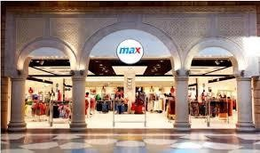
□Max International (P) Limited was incorporated in India in 2006 by the Landmark Group, Dubai. They have a strong presence in the Gulf, Middle East and Cyprus, and have already made a mark for themselves in India. The first of their stores in india in 2006 in indore, Madhya Pradesh.

□Max in India has already invested Rs.400 crore and plans an additional investment of Rs.100 crore in the next two years by setting up two more stores. They are expecting a turnover of 12 to 13 lakh a day, which adds up to 43 to 45 crore a year. They expect 50-60% of their shoppers to fall in the category of the people with high disposable incomes with an attitude to shop at a drop of a hat.

- Service quality is a perfect level feeling when customers come into contact with the service Rust and Oliver, the pursuit of service quality is an important factor for enterprise ensure long-term competitive advantage. Parasuraman suggested that in order to improve customer service satisfaction, company should be considered into the service intangibility, inseparability, variability and perishability these four aspects. The good customer service is all about bringing customer back and sending them away happy. No matter in what kind of enterprises, listen to you customers and deal with customer changeable demand and complaints. Sometimes make the questionnaires or survey for the customer's new need and expectation. This is also the good service method to meet customer satisfaction.

□“We are able to leverage our experience in the industry and our extensive network to source some exclusive imported merchandise and offer it to our customers at prices that are competitive,” says Mr.Harish Kumar Arumugam, Vice President, Operations, Max (Tamil Nadu ) Glassware from Spain, crockery from U.K and SriLanka., teen-fashions from China and Thailand, are some of the international products that are available at the Max store.

- Max opened its first store in indore, Madhya Pradesh, India in2006. Each Max store offers women’s wear, menswear, kids wear, footwear & bags, beauty & skincare, accessories (watches, fragrances, sunglasses) & more.
- The Indian customer initially accepted everything that was offered to them. But form the 90‟s the trend changed and the market became more customer driven Customers became more specific about what they wanted and did not pick up anything and everything that was given to them. In short, they became very choosy and needed alternatives to choose from. These in turn made the Indian customers more knowledgeable about the products and facilities and have now become tough critics, savvy purchasers, value driven spenders and practical

□thinkers when it comes to shopping. The demand for their time at work and home has made the customers extremely selective about how they would spend their limited time on shopping.
□Due to the increasing demand of customers for variety and convenience,
under one single roof and the concept of shopping malls started taking shape in India. Though the concept came from the west, when it was introduced in India, it was according to Indian tastes and preferences. Shoppers‟ stop was the 1st shopping mall to start in India. It was promoted by Mr.K. Raheja, a prominent Mumbai- based builder, opened the 1st outlet in Andheri, Mumbai in 1991. Initially it undergo a fair share of growing pains, but slowly it caught on and has now been very well accepted by the masses.

□Max International Pvt. Ltd is led by Shital Mehta, who is the managing director of the company.
- Landmark Group's business in India, which started with the Max stores, has now expanded to include Home Centre, Max, and Easy buy. The Group's foray into e- commerce in India began in January 2016 with Landmarkshops.in, which was replaced by three separate brand sites and apps for Max, Home Centre and Max in January 2017.
- There are the main two types about price. One is Value-based pricing and other is Cost-based pricing (Kotler, et al., 2008). If the company chose the first type, it must regard customers as the core value, first understand the customer needs, what the customers’ desire value, and then the company can set the cost follow by customer demand identification. The second type is treating suppliers or manufactures as the core to decide the cost, this may not able to be able to satisfy customers’ demand. Besides, the company can also choice to set the high price or low price for its product, but need to care many aspects when it decide price level, for instance, quality and market price sensitive. For promotion aspect, The company can do some activities like making advertisement, sale promotion or use public relationships to attract customer to buy its product. Meantime, make communication with customers; know customer’s demand and feedback to help it design the message. As the result, there will be more loyal customers and achieve benefits between each other When deciding the place part, the economic, population and crowd degree are important
- causes for a company to choose the sale place. It’s the common phenomena that a company like setting place where it’s in a big city, in downtown such great places. The managing marketing channel is also the part for place choice.
Especially the Vertical marketing system is the main channel organization for a company to think out. The company should combine the own condition to decide whether the Corporate VMS, Contractual VMS or Administrated VMS is suitable (Kotler et al., 2024)

landmark group
Our journey started in 1973with a single store in Bahrain. Since then, we have grown into a global retail and hospitality group. The proud creator of 25 plus value led, own-built brands across retail, hospitality, food, and leisure.
- Over the years, our UAE - based group has evolved into a comprehensive retail and hospitality entity, with over 2200 retail stores, leisure, and hospitality outlets, panning the GCC, Middle East, India, Southeast Asia, and Africa. Today, Landmark Group is one of GCC's largest omnichannel retailers and India's top home and fashion retailer.
- We take immense pride in the organic growth of our retail brands, which have blossomed into household names. From Max, Splash, Baby shop, Centrepoint, Shoe mart, Home Centre, Emax, Fitness First, to Fun City, to name a few, our brands span across a multitude of categories, enriching the lives of countless families over the past decade.

Founders

Micky Jagtiani: An entrepreneur at heart, Micky laid the foundation and spearheaded the growth of the Group across different geographies and industries. Driven by his insight, conviction, and passion for excellence, Micky led by example, inspiring Landmark's present culture of integrity that we live up to every day. It's his vision that is the inherent driving force behind our business today.

Renuka Jagtian: For over three decades, Renuka has guided the Group's corporate strategy making Landmark Group the region’s largest omnichannel retailer of trusted, homegrown brands. Renuka has been instrumental in creating multiple brands and new concepts. She led the Group's digital transformation almost a decade ago, pioneering omnichannel retail across the industry, a journey that continues today.
  - Landmark Group's Renowned Retail Brands

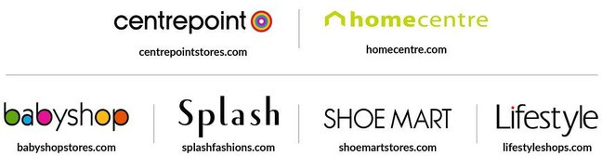

Product Range

    - Categories of Apparel : Max Fashion offers a wide range of apparel catering to men, women, and children. The clothing categories include casual wear, formal wear, ethnic wear, activewear, and seasonal collections. The brand is known for providing trendy and affordable clothing options that appeal to a diverse customer base.

    - Footwear and Accessories: In addition to clothing, Max Fashion provides a variety of footwear options, including casual shoes, formal shoes, sandals, and sports shoes. The brand also offers accessories such as bags, belts, sunglasses, watches, jewelry, and scarves to complement its apparel collections.

    - Seasonal Collections: Max Fashion launches exclusive seasonal collections for occasions like summer, winter, festivals, and special events. These collections feature unique designs, fabrics, and colors tailored to the fashion needs of different seasons. The festive collections, in particular, are highly popular among customers.

    - Special Collaborations: Max Fashion often collaborates with designers and influencers to launch limited-edition collections. These collaborations help the brand stay trendy and attract a wider audience. The brand also engages in partnerships with movie franchises and celebrities to promote exclusive merchandise.

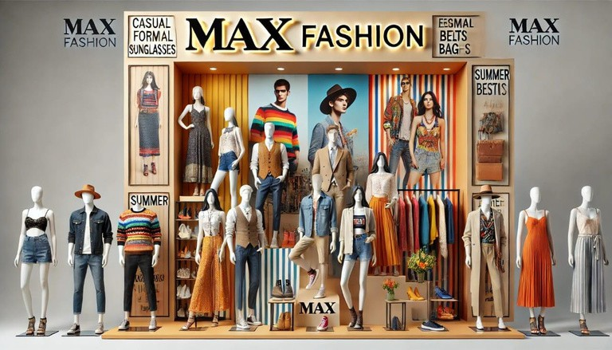

Supply Chain and Operations

Manufacturing Process

Cost-effective and efficientmanufacturing process.

Raw materials sourced frommultiple suppliers for quality control and affordability.

Production process includes:

Design

Fabric selection Stitching
Quality inspection

Packaging

Products manufactured in key textile-producing countries like India, Bangladesh, and China.

Logistics and Distribution
Well-structured logistics and distribution network.

Central warehouses distribute products to retail stores and online customers.
Third-party logistics providers ensure efficient transportation.

Uses modern inventory management systems to prevent stock shortages and ensure timely replenishment.

Retail Store Operations

□Numerous retail stores in shopping malls and standalone worldwide.
locations

□ Designed for a seamless shopping experience with:
□TWrieallr-oorgmans ized sections
□Helpful staff
□

Store managers focus on:

□EMnhaianntcaiingincgussttocmkelresveerlvsice
Meeting sales targets

E-Commerce and Online Presence

□Strong online presence through official website and mobile app.

Customers can:
□PBlarocewoserdleartsest collections
□Track shipments
□

□Partnerships with e-commerce platforms like Amazon, Flipkart, and Noon for wider reach.

Digital marketing strategies include:
□ Online ads
Influencer collaborations
□Promotional campaigns to boost sales.
□
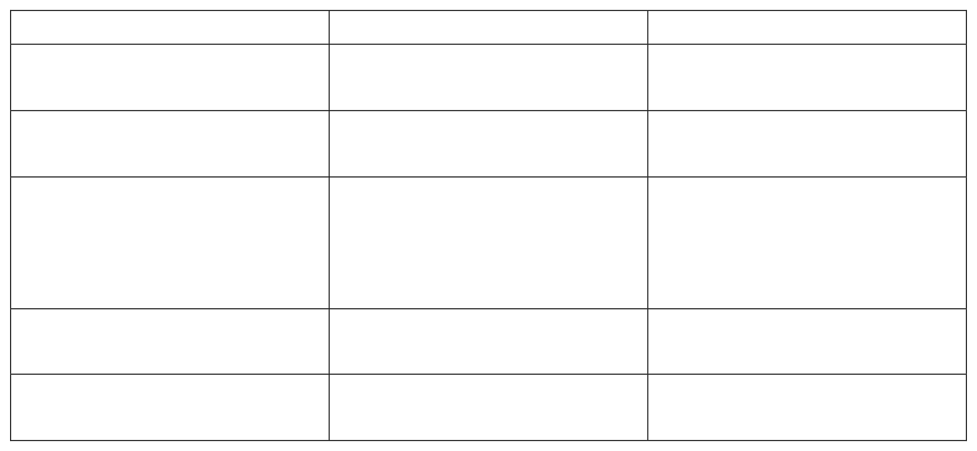
  - Comparison
Features Target Market
Logistics Model
Vishal Mega Mart Budget-conscious Customers(Value Retail)
Max Fashion
Mid-
Range
Customer
Fashion Logistics
Direct Procurement from Third-Party
Warehousing
Manufacturing
Support
Centralized + Regional Distributing
Warehousing
Warehousing regions
across
E- Commerce Presence
Limited
Store Expansion
Strong online Presence
(Website+ Marketplace) Focuses on Smaller cities Operates in Malls and
Prime Locations



Competitive Analysis

Major Competitors in the Market

Max Fashion competes with Reliance Trends, Vishal Mega Mart, Pantaloons, Zudio, H&M, and Zara.
Competition varies based on pricing, target audience, and regional presence.

Comparison of Pricing Strategies
Max Fashion: Affordable, value-for-money pricing. Reliance Trends: Discount-driven model with frequent sales. Pantaloons: Mix of budget and premium pricing.
Zudio: Ultra-low prices, cost-effective model.
H&M/Zara: Fast fashion with higher price points.

Market Share Analysis
Max Fashion has a strong presence in the value fashion segment. Reliance Trends and Zudio are rapidly expanding in India. International brands hold a smaller market share in the affordable segment. Online marketplaces add to competition with discounts and exclusive
collections.

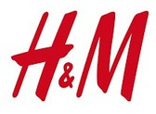


SWOT Analysis
Strengths: Brand recognition, affordability, strong retail and e-commerce presence.
Weaknesses: Limited premium segment presence, reliance on third-party logistics.
Opportunities: Expansion in smaller cities, growth in digital shopping.

Threats: Rising competition, evolving fashion trends.



Factor influencing customers satisfaction

- Product Quality: Customers expect durable, stylish, and high-quality clothing.
- Pricing: Competitive pricing influences purchase decisions.
- Variety: Wide range of products catering to different tastes and preferences.
- Store Ambiance: A pleasant shopping environment enhances customer

experience.
- Staff Behavior: Friendly and knowledgeable staff contribute to a positive experience.
- Customer Service: Efficient handling of queries and complaints impacts satisfaction.
- Promotions and Discounts: Offers and loyalty programs attract and retain customers.

Challenges Identified
- Highpricing for premiumproducts.
- Limited sizes for some clothing categories.
- Occasional delays in billing and checkout processes.

CHAPTER – 4
DATA ANALYSIS AND INTERPRETATION

Gender wise classification of respondents
Table4.1
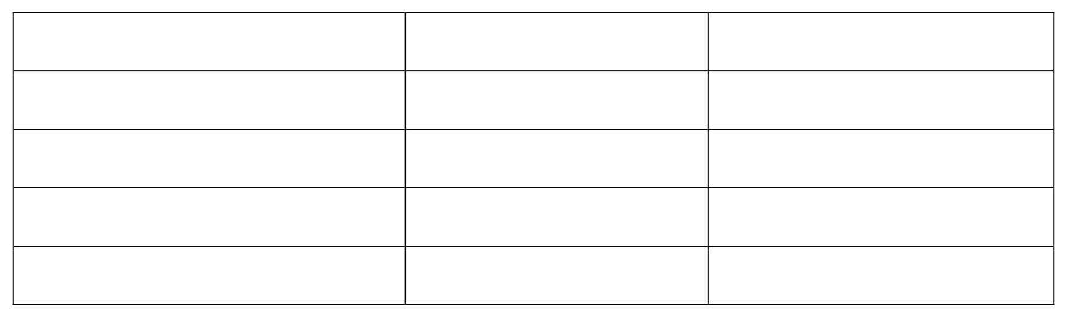
Gender
Male
Female
Prefer not to say Total
Frequency
60 79
140
1
Percentage
42.86%
56.43%
0.71%
100%

Interpretation
From the fig 4.1 we can see that, 56.43% of respondents are female, 42.86% are male and 0.71% were prefer not to say.

Fig 4.1
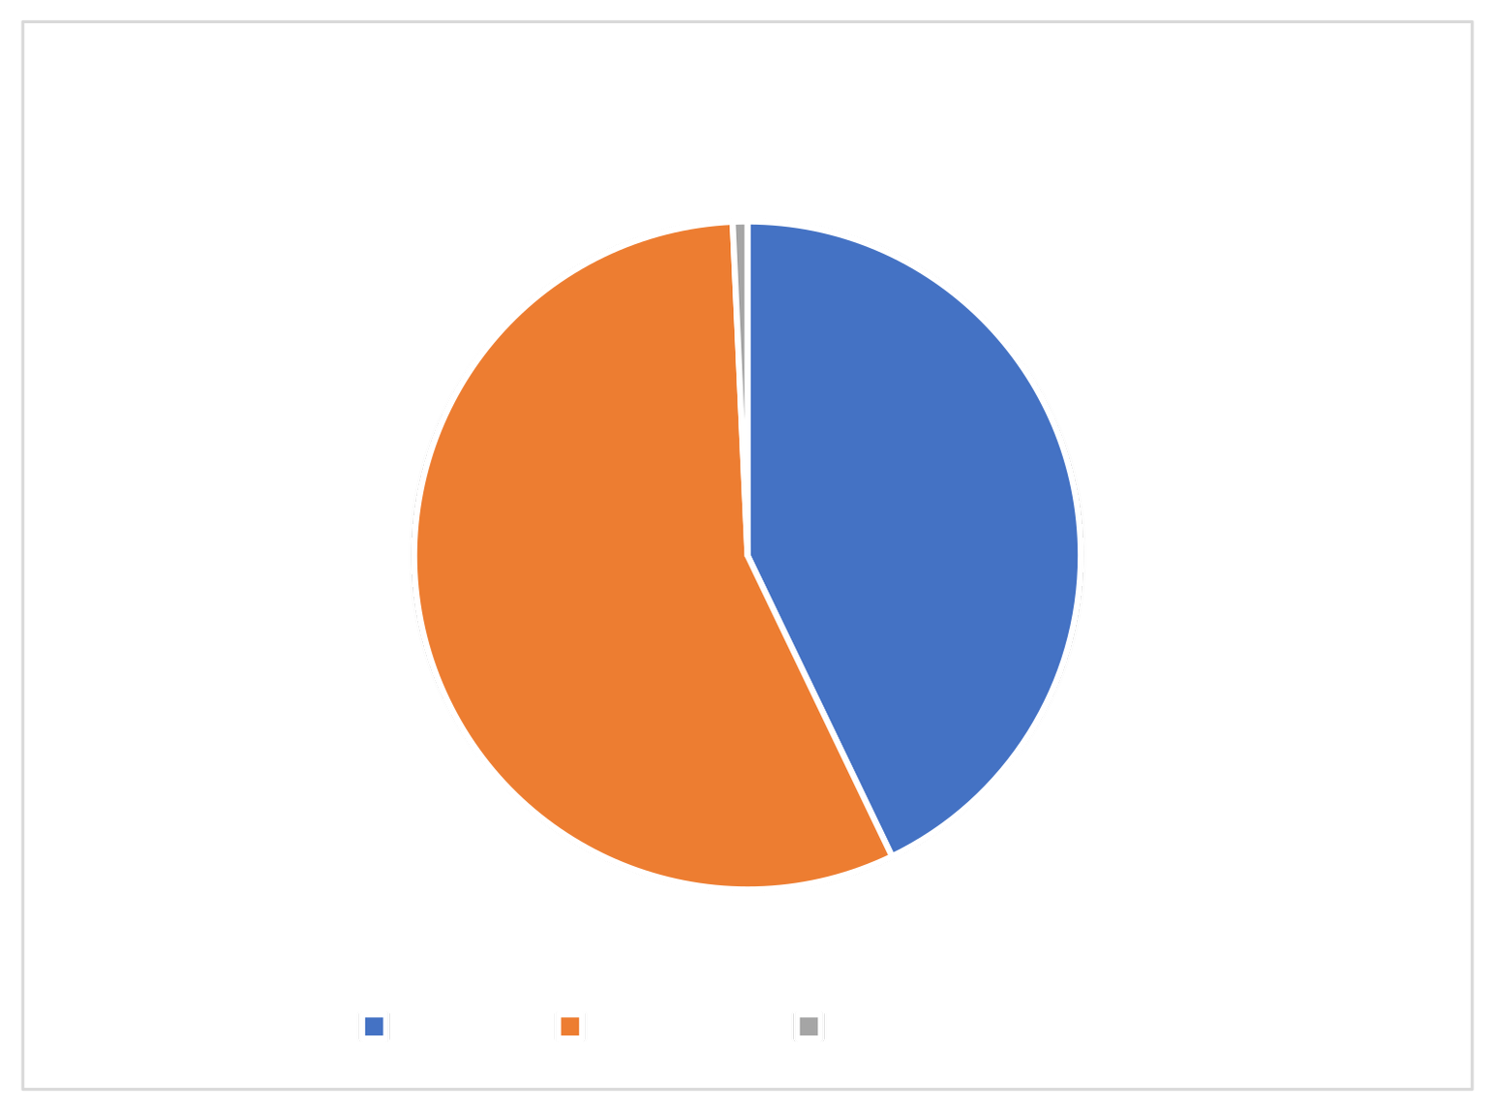
Gender of respondents
0.71%
42.86%
56.43%
Male
Female
Prefer not to say
:

Age wise classification of the respondents

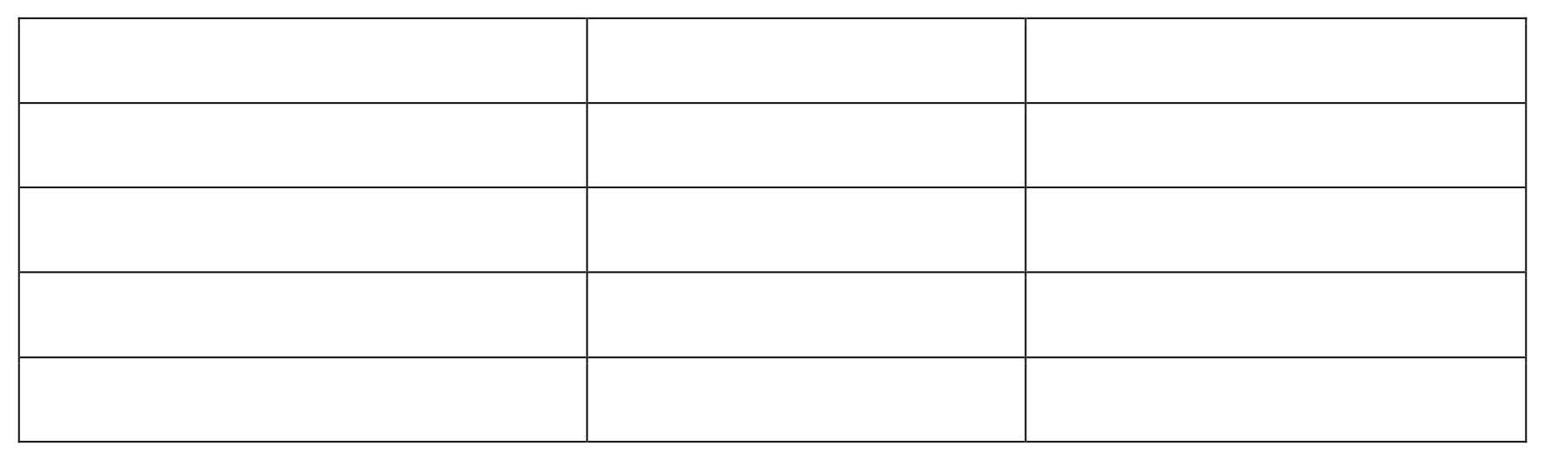
Table 4.2

Age group 18 | Frequency | Percentage
to 24 years 25 | 94 34 12 | 67.14%
to 35 years | 140 | 24.29%
Above 35 years |  | 8.57%
Total |  | 100%

Interpretation
From the figure 4.2 we can see that, majority of our respondents i.e., 67.14% were belongs to the age category of 18-24 years, followed by 24.29% of 25-35 years.
8.57% of above 35 years.

Fig 4.2
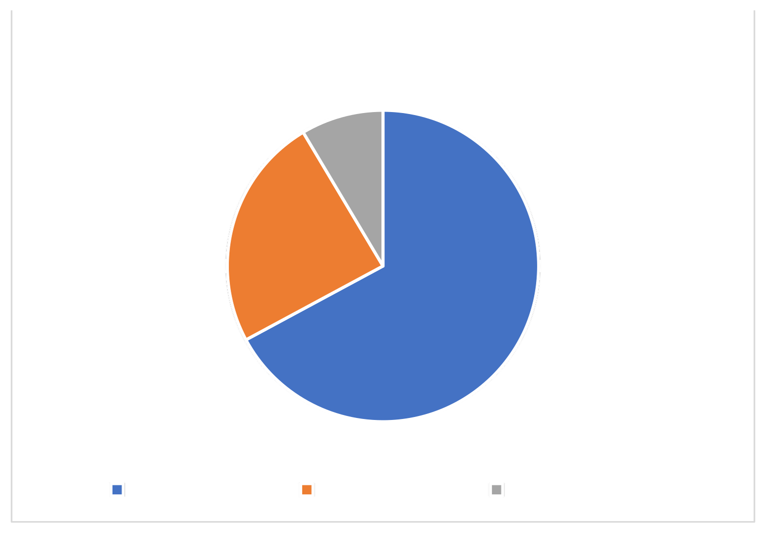
Age Group of respondents
8.57%
24.29%
67.14%
18 to 24 years
25 to 35 years
Above 35 years

Showing the customers frequency of the purchase
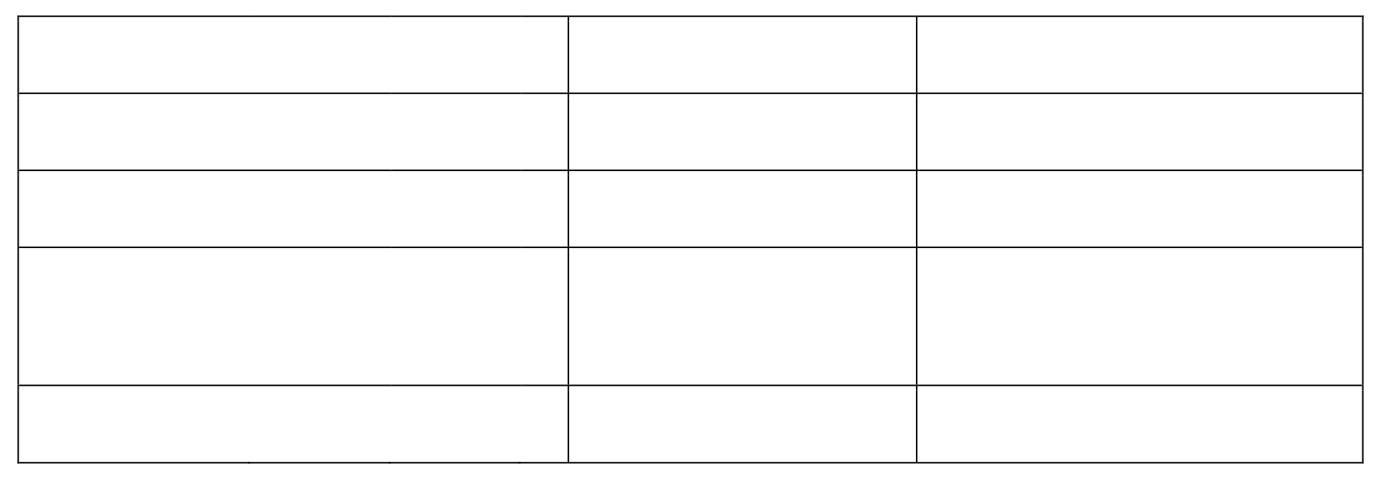
Table 4.3

Response |  |  |  | Frequency | Percentage
Monthly |  |  |  | 24 35 81 | 17.14%
Quarterly |  |  |  |  | 25%
Seasonally/ occasion | during | offers | in |  | 57.86%
Total |  |  |  | 140 | 100%

Interpretation

From the fig 4.3 it can be seen that, 57.86% of respondents purchase in seasonally/ during offers in occasion and 25% of respondents in quarterly. Only 17.14% of respondents in monthly.

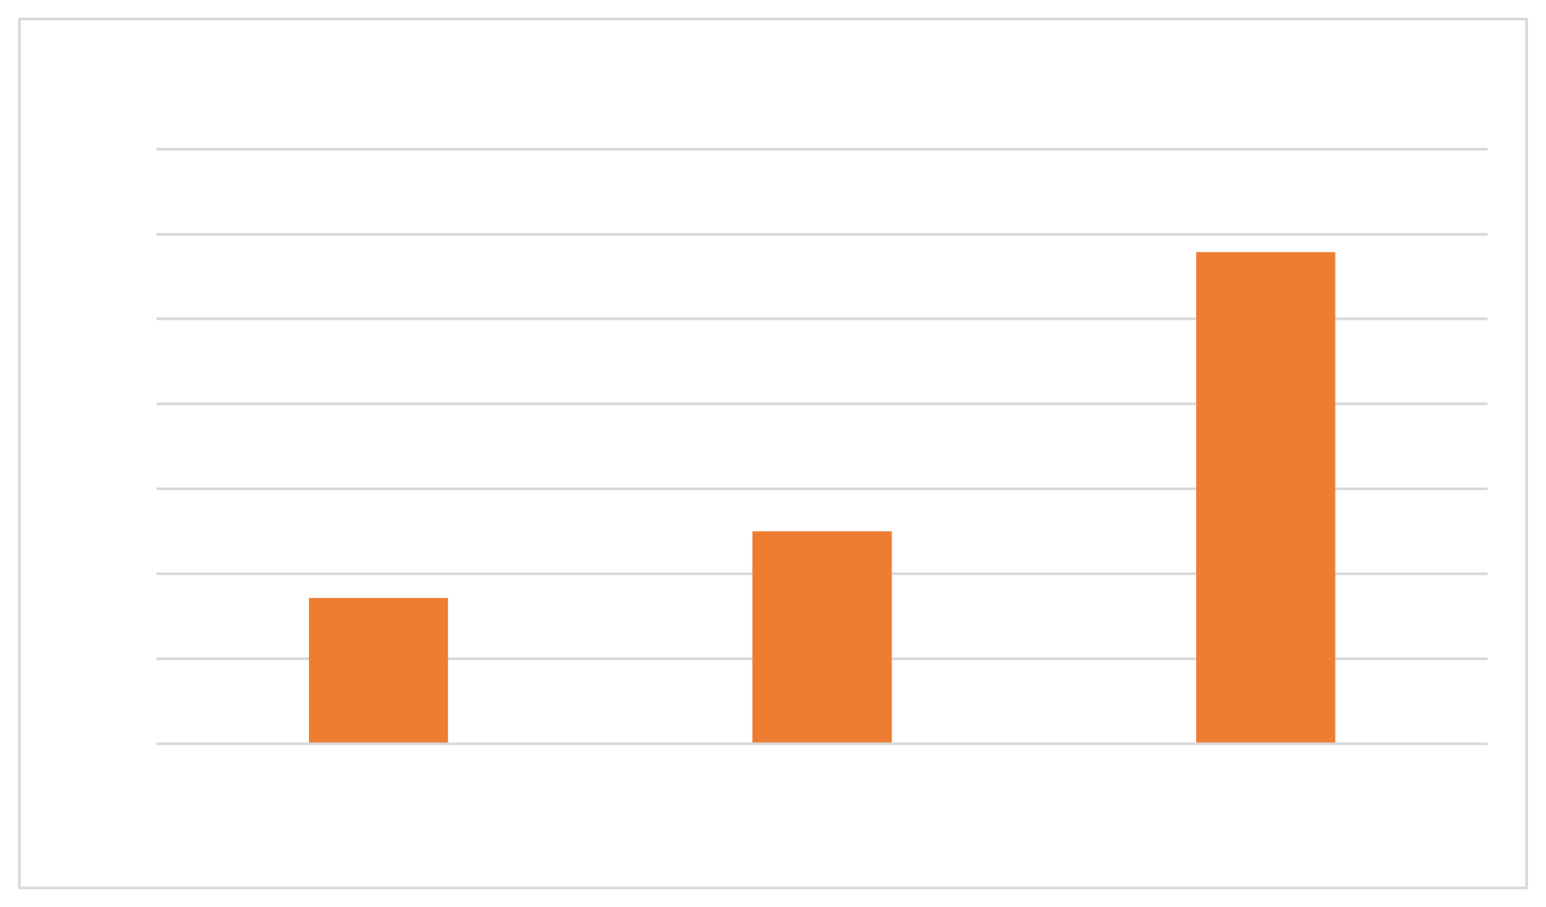
Fig 4.3
Customers frequency of the purchase
70%
in occasion

60% |  |  | 57.86%
50%
40%
30% |  | 25%
20% | 17.14%
10%
0%
 | Monthly | Quarterly | Seasonally/during offers

Showing factors that influence customers to buy from max fashion
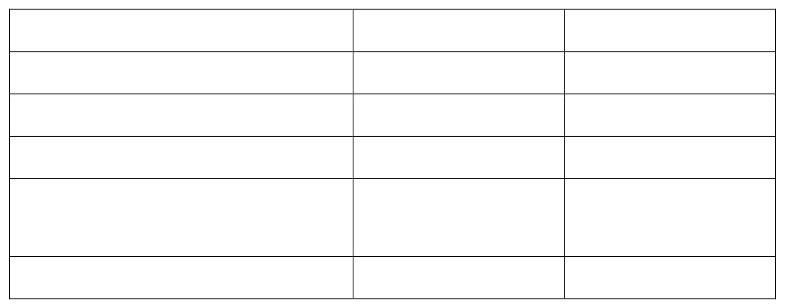
Table 4.4

Response | Frequency | Percentage
Newspaper | 1 | 0.71% 15%
Tv | 21 | 35%
Through store displays | 49 | 49.29%
From reference group like friends & family members | 69
Total | 140 | 100%

Interpretation

From the fig 4.4 we can see that, 49.29% respondents influenced to buy from max fashion from reference group like friends & family members, followed by 35% through store
displays and 15% through Tv. Only 0.71% from newspaper

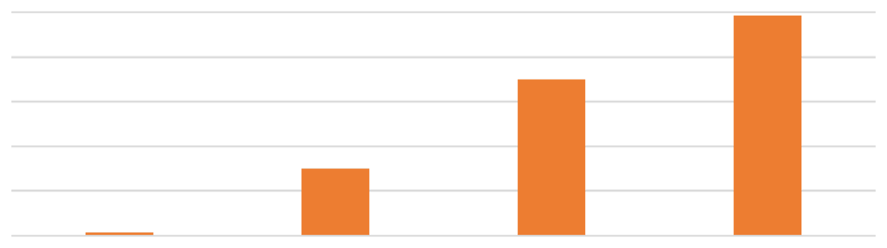

Fig 4.4
Factors that influence customers to buy from max fashion
49.29%
10%
0%
0.71%
Newspaper
Tv
Through store From reference
displays group like friends
& family members

60%
50%
40% |  | 35%
30%
20% | 15%

showing customer assistance process in max fashion shopping
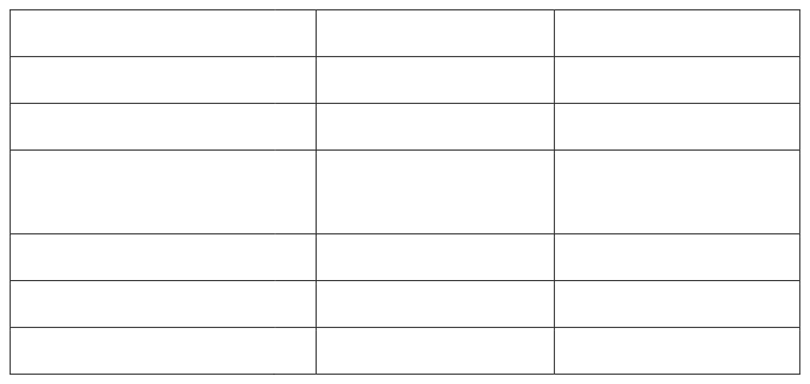
Table 4.5
Response Highly satisfied Satisfied
Neither satisfied nor
Frequency
28 92 20
Percentage
20%
65.71%
14.29%

dissatisfied
Dissatisfied | 0 0 | 0%
Highly dissatisfied | 140 | 0%
Total |  | 100%

Interpretation

From the fig 4.5, it can be seen that 65.71% of the respondents are satisfied with the customer assistance process in max fashion shopping followed by, 20% were highly satisfied, 14.29% neither satisfied nor dissatisfied and 0% of respondents dissatisfied and highly dissatisfied with the process.

Fig 4.5
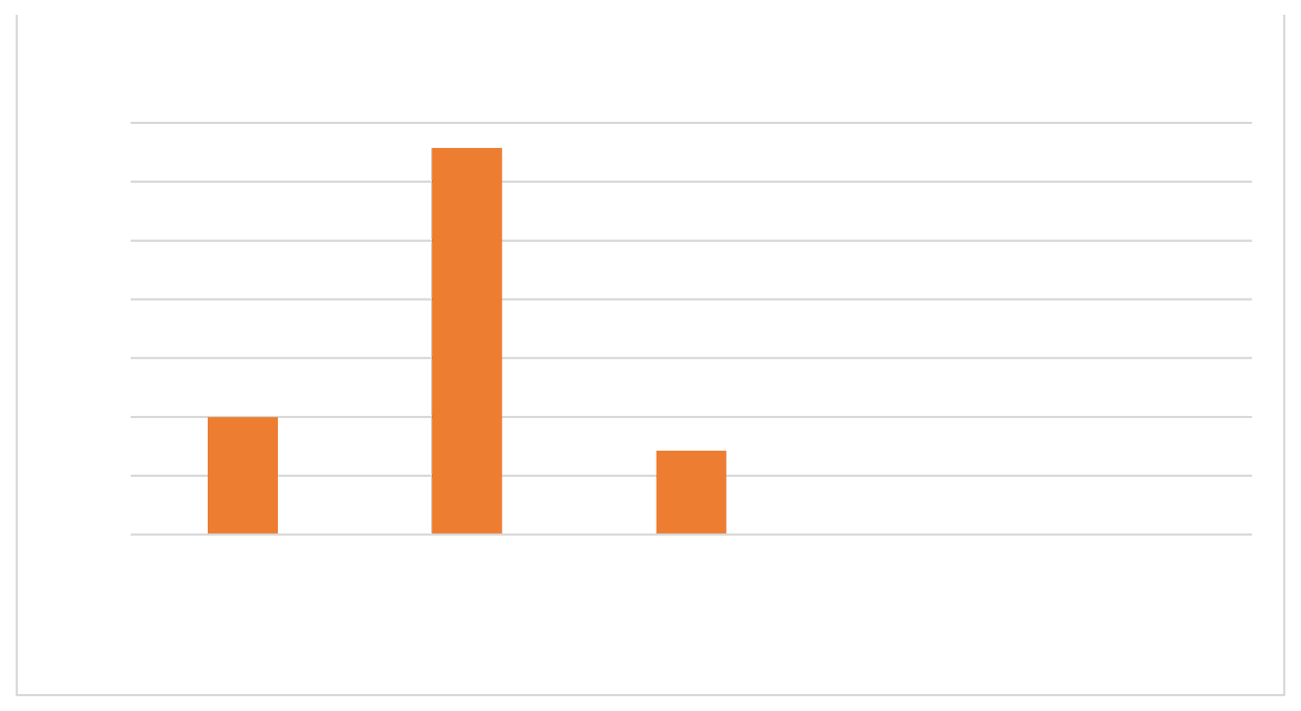
70%
60%
50%
40%
30%
20%
10%
0%
Customer assistance process in max fashion
65.71%
20%
14.29%
Highly Satisfied
satisfied
Neither satisfiednor dissatisfied
0%
Dissatisfied
0%
Highly
dissatisfied

showing customers satisfied with the billing system process
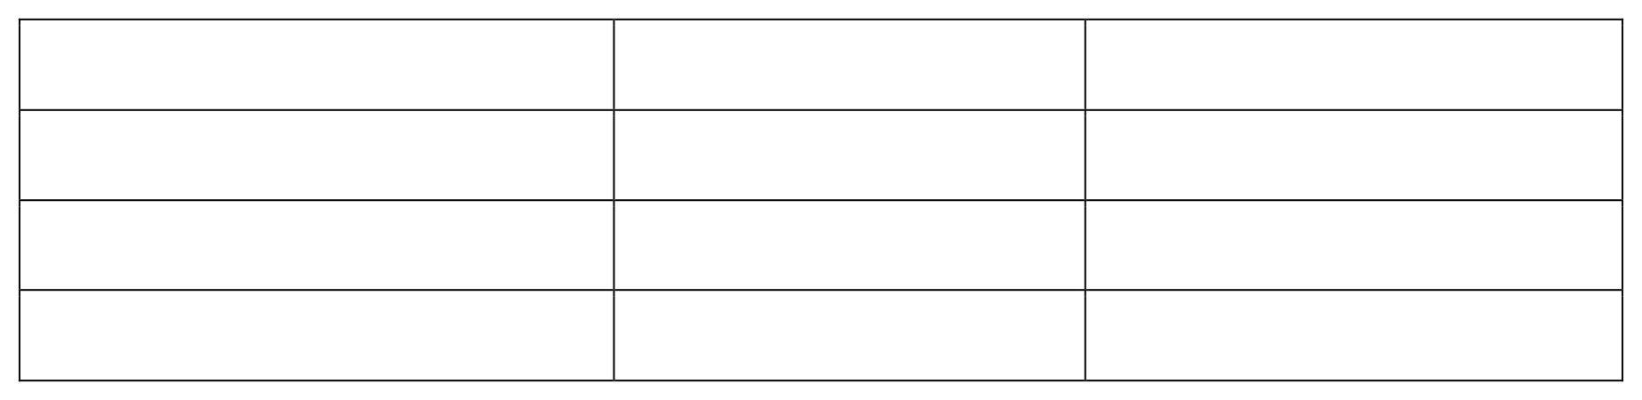
Table 4.6

Response | Frequency | Percentage
Yes | 132 | 94.29%
No | 8 | 5.71%
Total | 140 | 100%

Interpretation
From the fig 4.6 it can be seen that, 94.29% of respondents are satisfied with the billing system process of max fashion store and 5.71% of respondents are not satisfied with the process.

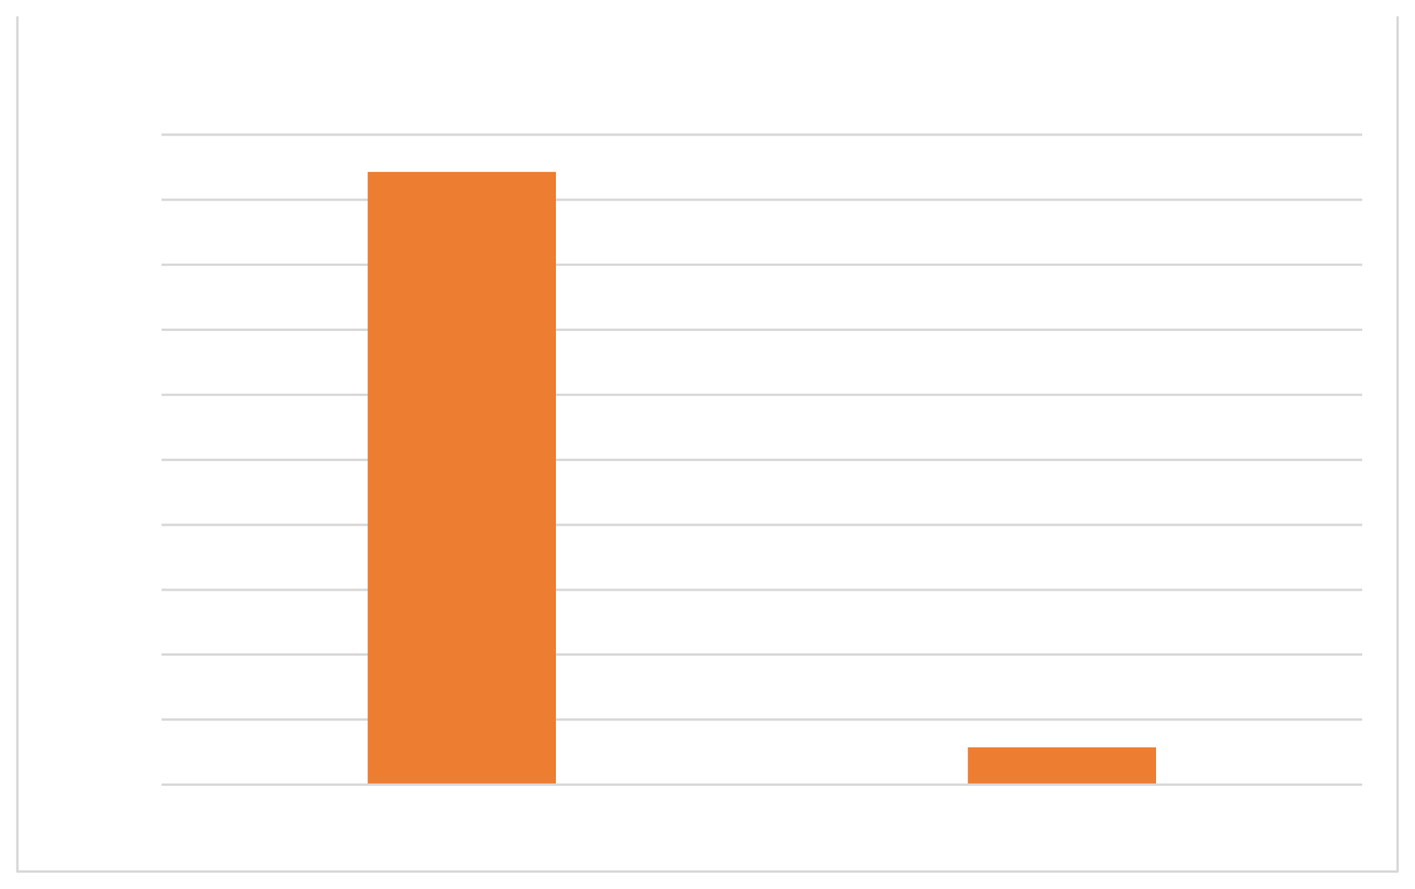
Fig 4.6
100%
90%
80%
70%
60%
50%
40%
30%
20%
10%
0%
Customers satisfied with the billing system process
94.29%
5.71%
Yes
No

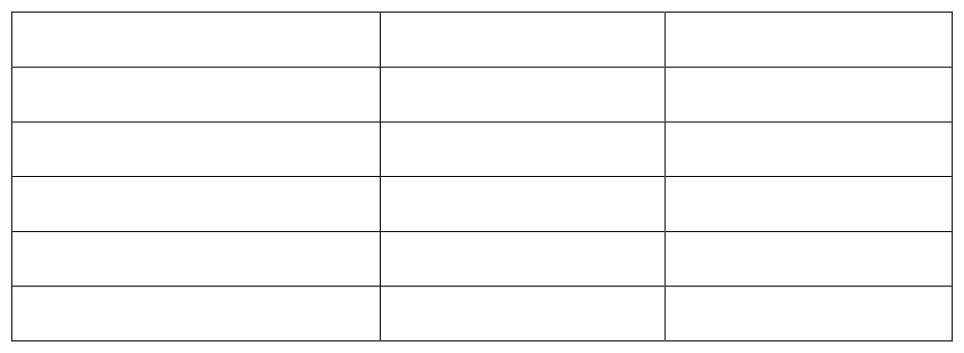
showing promotional services that customers expect
Table 4.7

Response | Frequency | Percentage
Discount/ attractive offers | 110 22 8 0 | 78.57%
Coupons | 140 | 15.71%
Free gifts |  | 5.71% 0%
Game shows |  | 100%
Total

Interpretation

From the fig 4.7 it can be seen that 78.57% of the respondents except the discount/ attractive offers from the max fashion store, followed by 15.71% expect through coupons. 5.71% through free gifts and 0% of respondents expect game shows from max fashion.

Fig 4.7
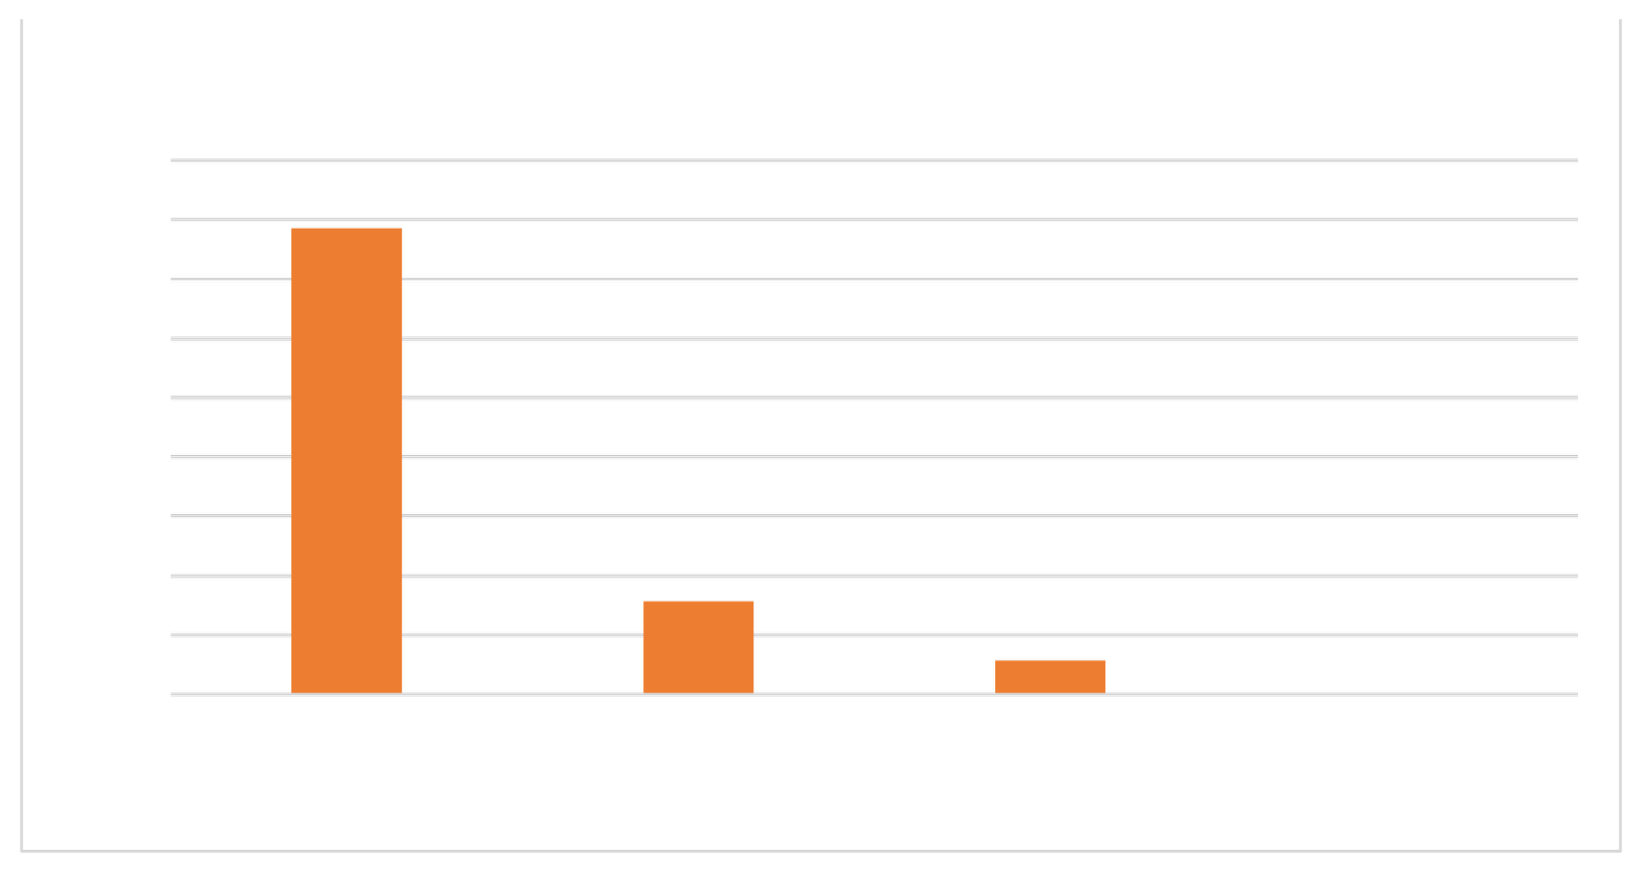
90%
80%
70%
60%
50%
40%
30%
20%
10%
0%
Promotional services that customers expect
78.57%
15.71%
5.71%
Discount/ attractive offers
Coupons
Free gifts
0 %
Game shows

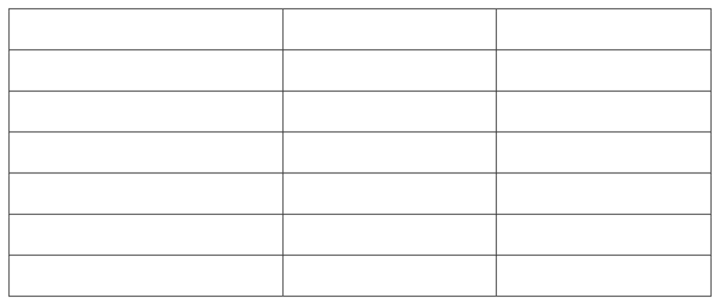
showing customers checking Max Buddy program while visiting retail store
Table 4.8
Response
Always
Most of the time Sometimes Rarely
Never
Total
Frequency
11 53 29 9
38 140
Percentage
7.86%
37.86%
20.71%
6.43%
27.14%
100%

Interpretation

From the fig 4.8 we can interpret that, 37.86% of respondents are most of the time checking Max Buddy program, followed by 27.14% never checking, 20.71% sometimes checking, 7.86% always checking, and 6.43% rarely checking.

Fig 4.8
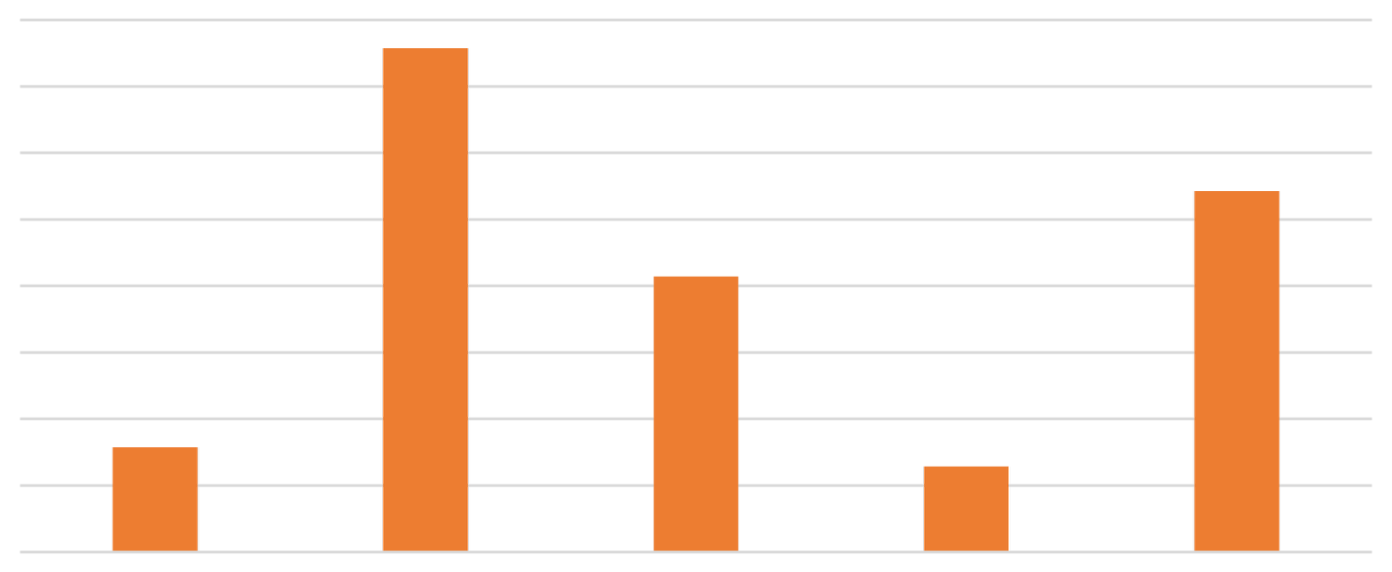

Customers checking Max Buddy program while visiting
retail store
40%
35%
30%
25%
20%
15%
10%
5%
0%
37.86%
27.14%
20.71%
7.86%
6.43%
Always
Most of the time
Sometimes
Rarely
Never

showing customers get any promotional coupons for future purchase
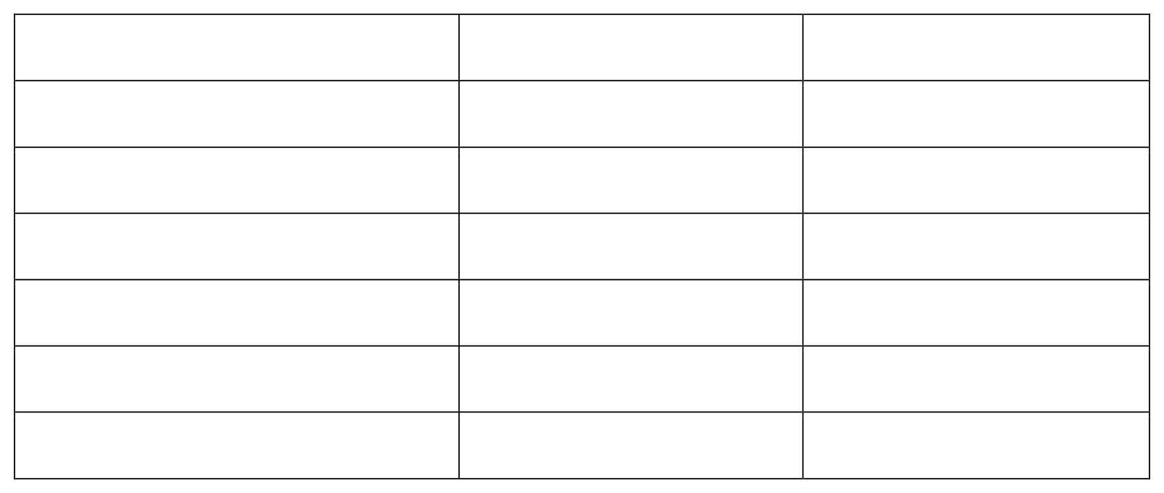
Table 4.9

Response | Frequency | Percentage
Always | 13 26 47 | 9.29%
Most of the time | 28 26 140 | 18.57%
Sometimes |  | 33.57%
Rarely |  | 20%
Never |  | 18.57%
Total |  | 100%

Interpretation
From the fig 4.9 it can be seen that 33.57% respondents sometimes get promotional coupons for future purchase through max store followed by, 20% respondents get rarely and 18.57% of respondents never and most of the time get promotional coupons. While 9.29% of the respondents get always.
Fig 4.9

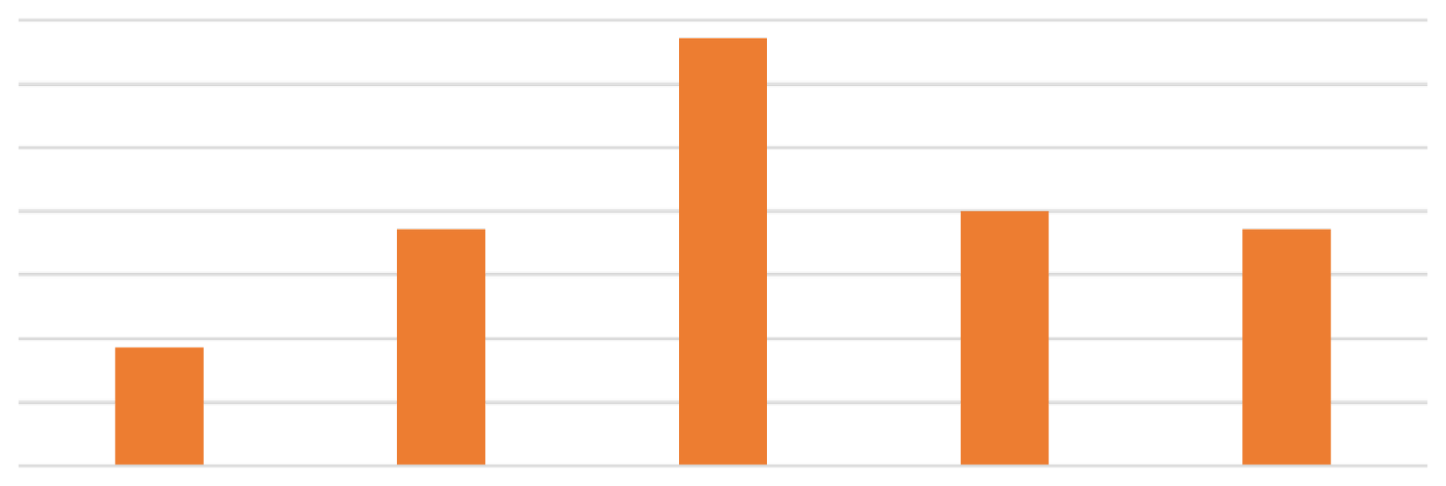

40%
35%
30%
25%
20%
15%
10%
5%
0%
Customers get promotional coupons for future purchase
33.57%
18.57%
20%
18.57%
9.29%
Always
Most of the time
Sometimes
Rarely
Never

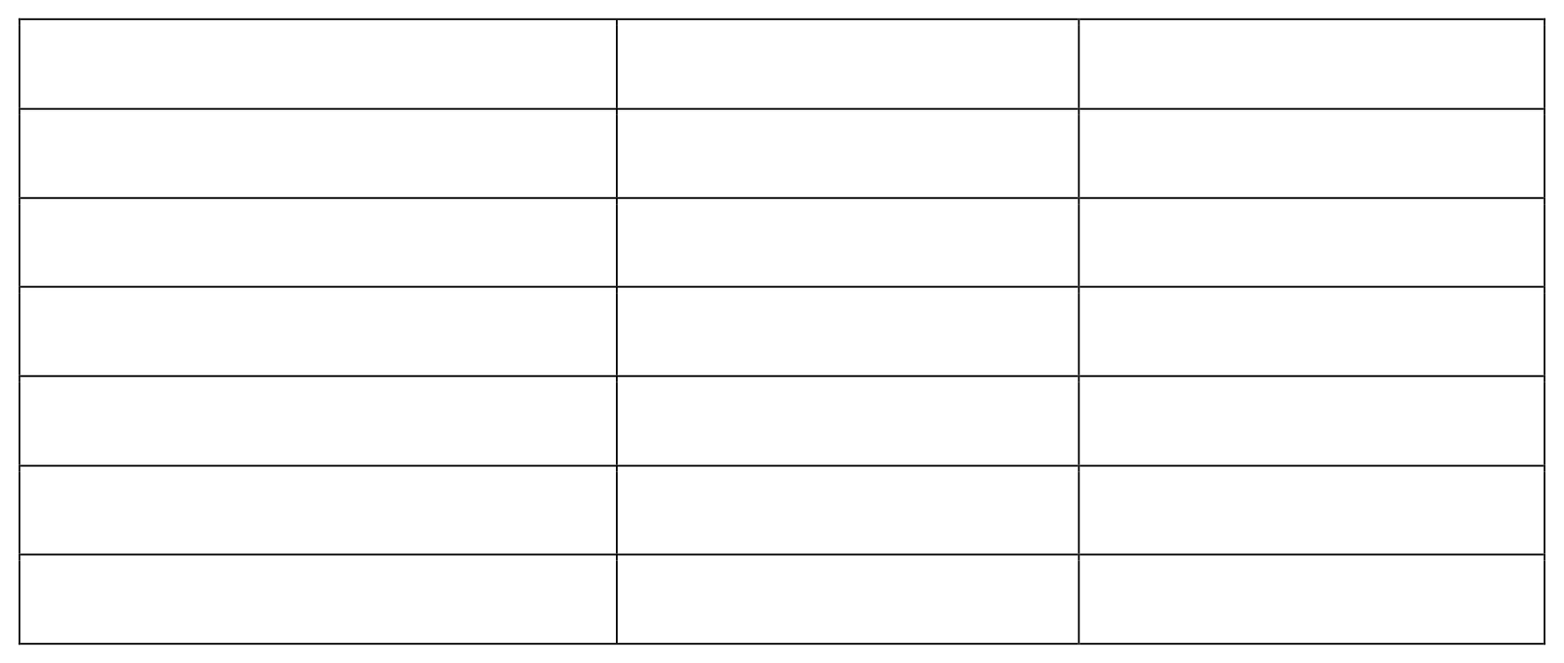
showing customers ever redeemed the promotional coupons
Table 4.10

Response | Frequency | Percentage
Always | 17 26 29 | 12.14%
Most of the time | 23 45 140 | 18.58%
Sometimes |  | 20.71%
Rarely |  | 16.43%
Never |  | 32.14%
Total |  | 100%

Interpretation

From the fig 4.10, it can be seen that 32.14% respondents never redeemed the promotional coupons in the max fashion store followed by, 20.71% sometimes, 18.58% most of the time, 16.43% rarely and 12.14% always redeemed.

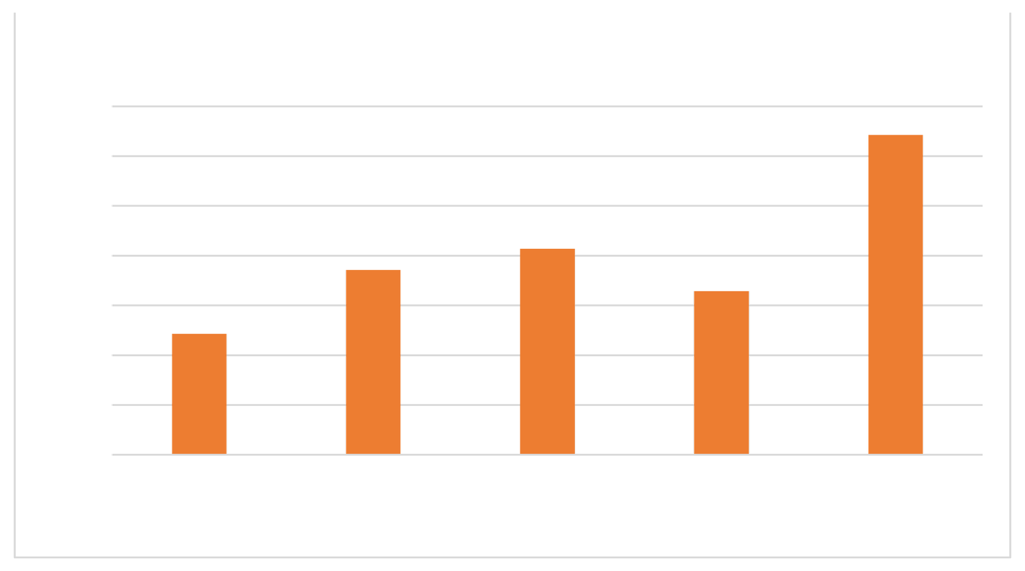
Fig 4.10
35%
30%
25%
20%
15%
10%
5%
0%
Customers ever redeemed the promotional coupons
32.14%
18.58%
20.71%
16.43%
12.14%
Always
Mostofthe
time
Sometimes
Rarely
Never

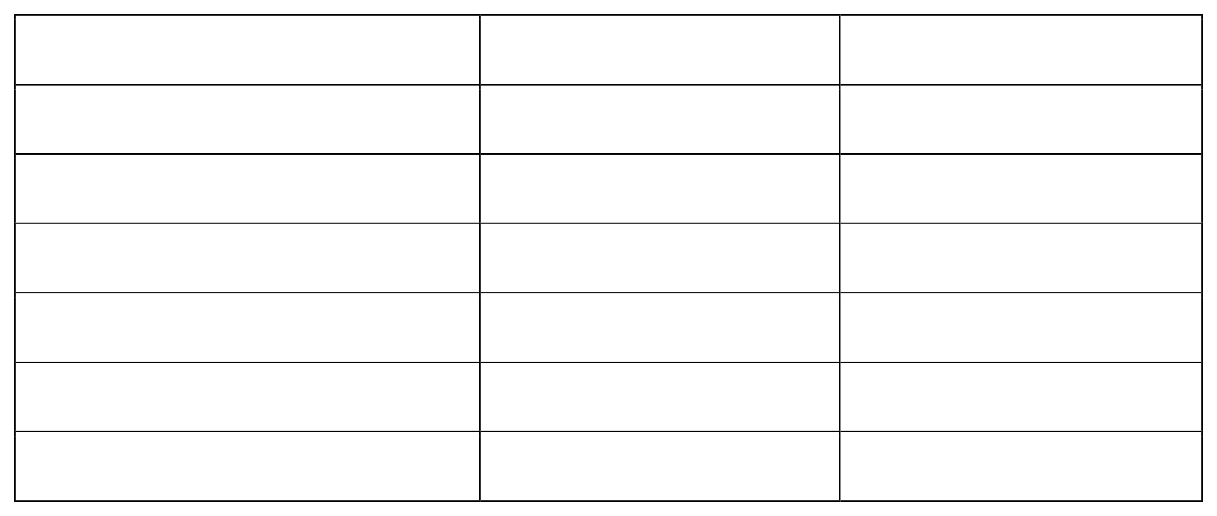
showing level of satisfaction for the Mens wear
Table 4.11

Response | Frequency | Percentage
Excellent | 24 51 55 6 | 17.14%
Very good | 4 140 | 36.43%
Good |  | 39.28%
Fair |  | 4.29%
Average |  | 2.86%
Total |  | 100%

Interpretation

From the fig 4.11, it can be seen that 39.28% of the respondents have good level of satisfaction for the Mens wear followed by, 36.43% of the respondents felt very good level of satisfaction, 17.14% felt excellent and 4.29% felt fair. Only 2.86% felt average.

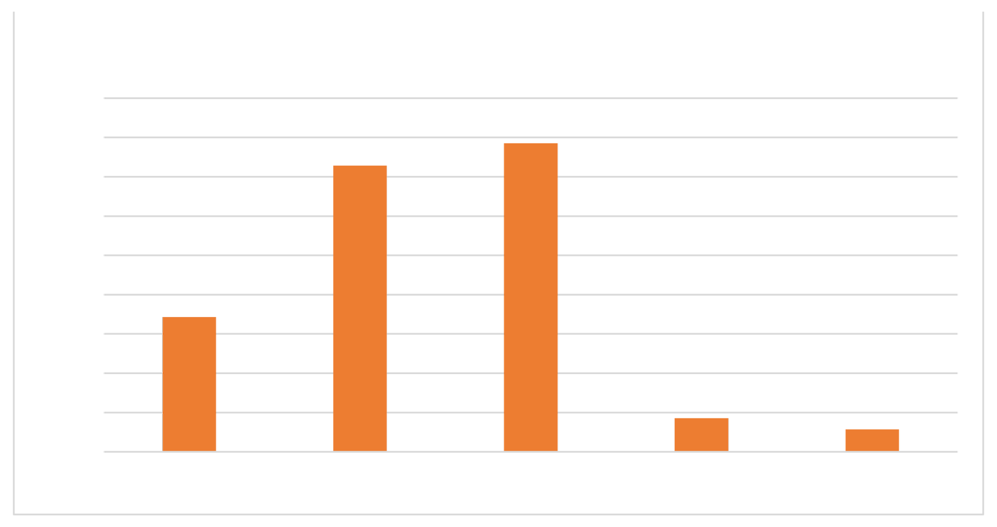
Fig 4.11
Level of satisfaction for the Mens wear
45%
40%
35%
30%
25%
20%
15%
10%
5%
0%
36.43%
39.28%
17.14%
4.29%
2.86%
Excellent Very good Good Fair Average

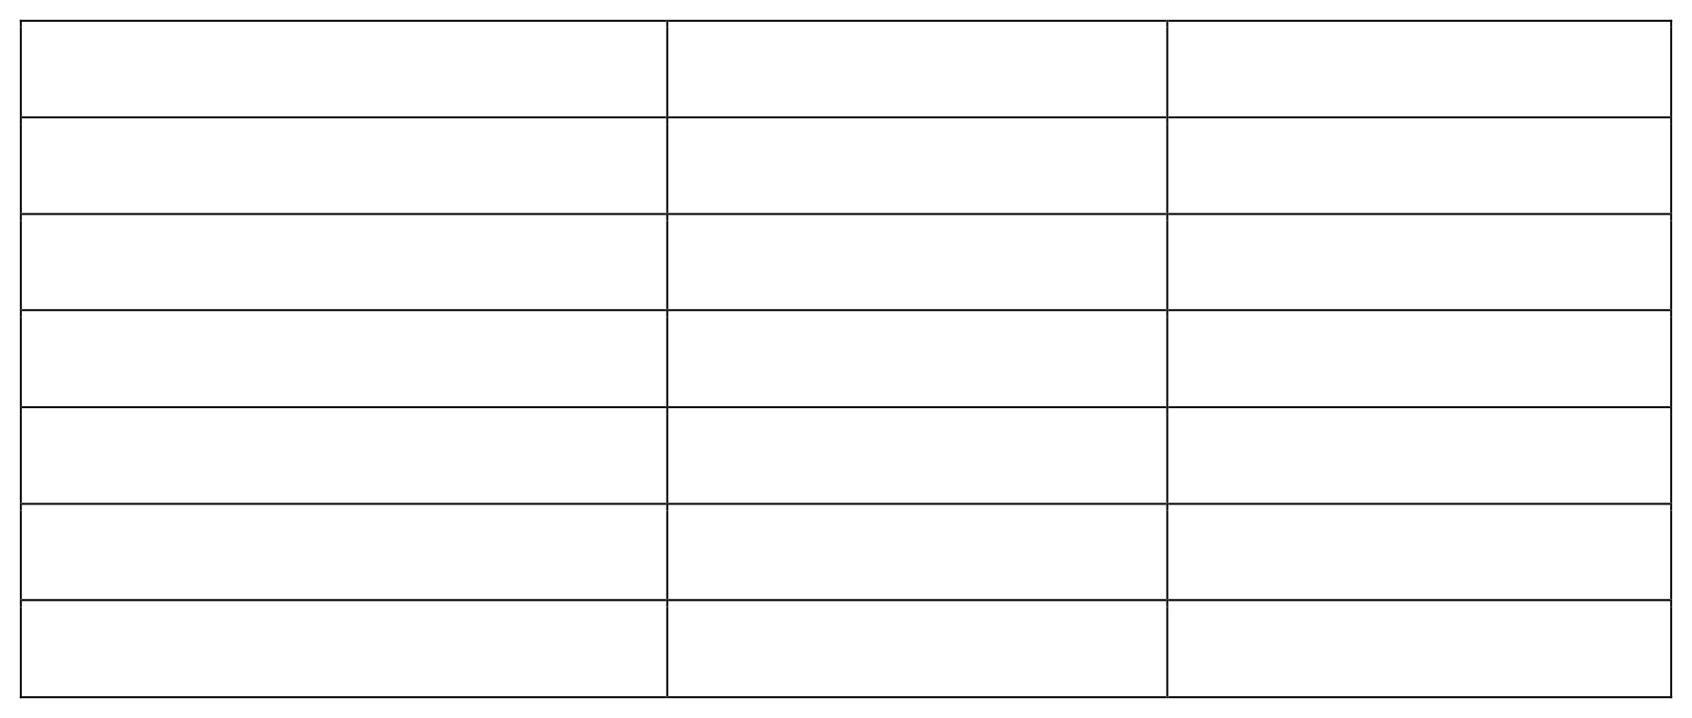
showing level of satisfaction for the Womens wear
Table 4.12

Response | Frequency | Percentage
Excellent | 24 55 49 5 | 17.14%
Very good | 7 140 | 39.29%
Good |  | 35% 3.57%
Fair |  | 5% 100%
Average
Total

Interpretation

From the fig 4.12, it can be seen that 39.29% of respondents felt very good level of satisfaction for the Womens wear of the max fashion store, followed by 35% felt good, 17.14% felt excellent and 5% felt average level of satisfaction. Only 3.57% felt fair.

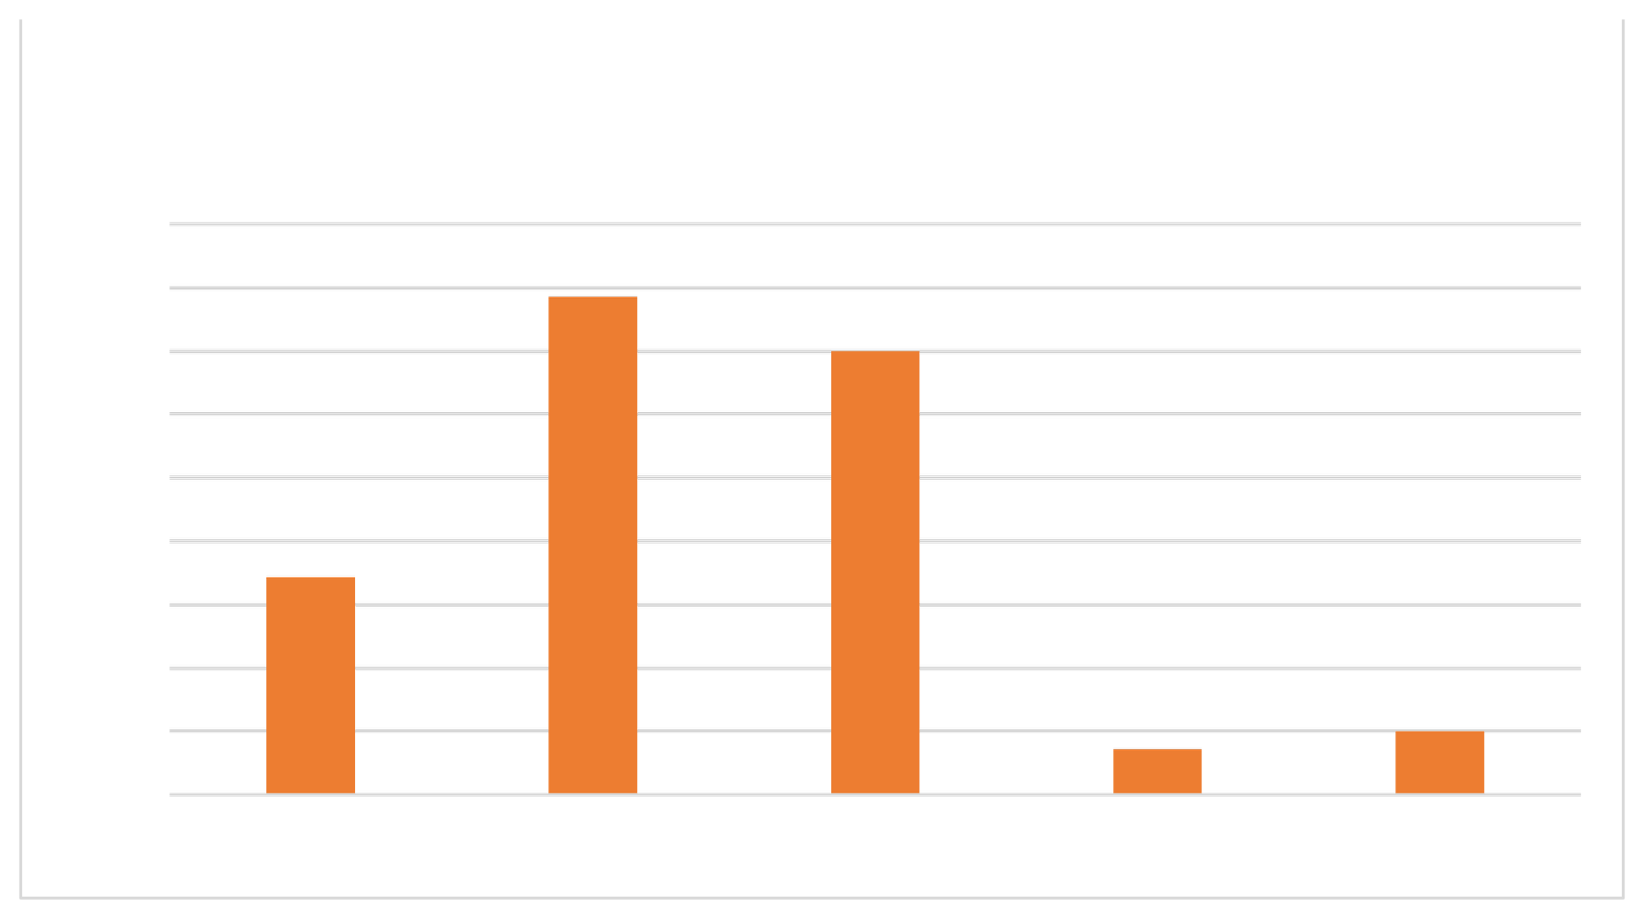
Fig 4.12
Level of satisfaction for the Womens wear
45%
40%
35%
30%
25%
20%
15%
10%
5%
0%
39.29%
35%
17.14%
3.57%
5%
Excellent Very good Good Fair Average


showing level of satisfaction for the Kids wear
Table3

Response | Frequency | Percentage
Excellent | 28 48 54 6 | 20%
Very good | 4 140 | 34.28%
Good |  | 38.57%
Fair |  | 4.29%
Average |  | 2.86%
Total |  | 100%

Interpretation

From the fig 4.13 it can be seen that, 38.57% of respondents felt good level of satisfaction for the kids wear in the max fashion store, followed by 34.28% felt very good, 20% felt excellent and 4.29% felt fair. Only 2.86% felt average level of satisfaction.

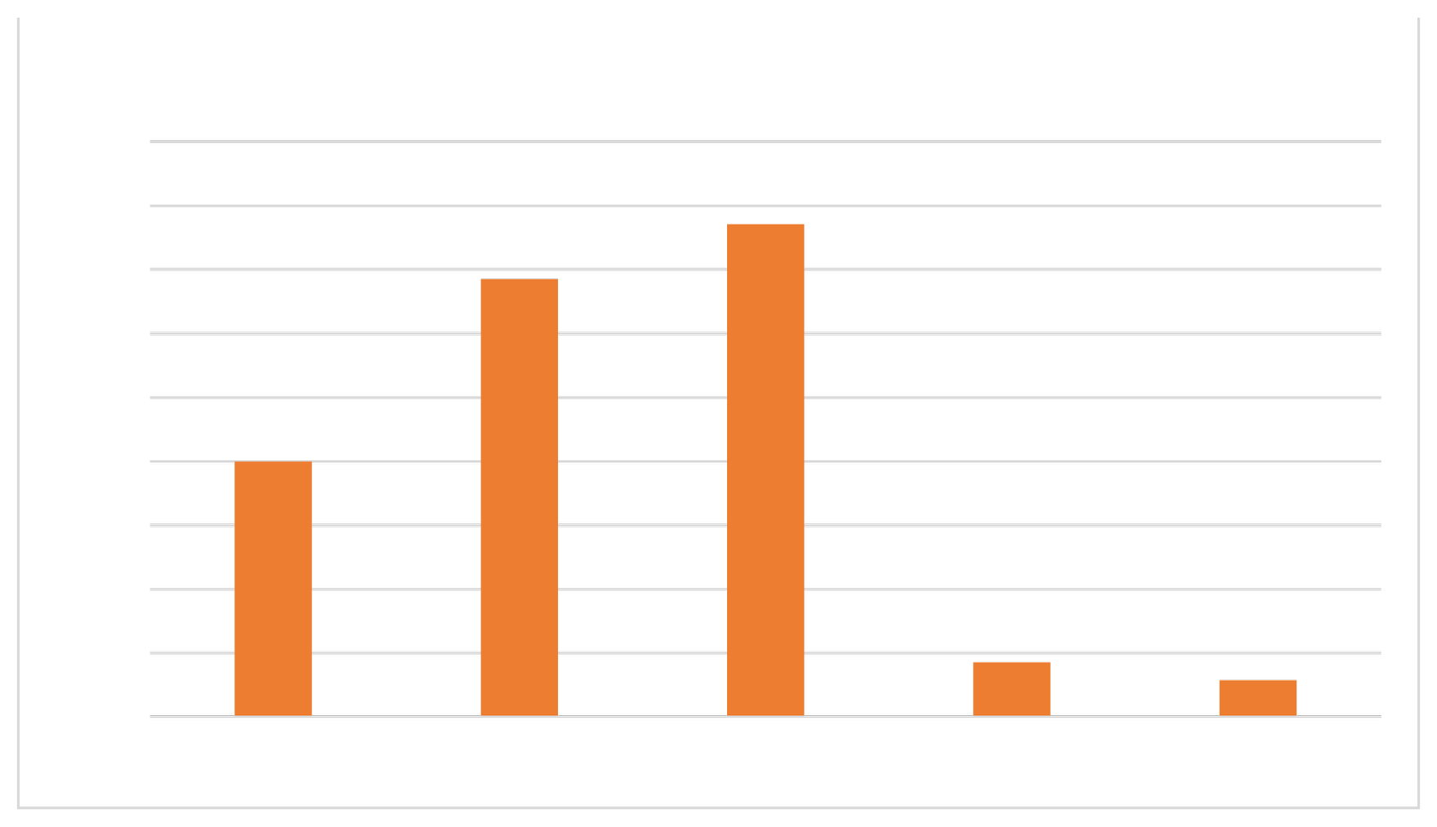
Fig 4.13
Level of satisfaction for the Kids wear
45%
40%
35%
30%
25%
20%
15%
10%
5%
0%
38.57%
34.28%
20%
4.29%
2.86%
Excellent Very good Good Fair Average


Showing level of satisfaction for the Foot wear & other accessories
Table 1.14
Response
Frequency
Percentage

Excellent | 28 35 57 | 20% | 25%
Very good | 12 8 140 | 40.72%
Good |  | 8.57%
Fair |  | 5.71%
Average |  | 100%
Total

Interpretation

From the fig 4.14 it can be seen that, 40.72% of respondents are good level of satisfaction for the foot wear & other accessories in max fashion stores, followed by 25% very good, 20% excellent and 8.57% felt fair. Only 5.71% felt average level of satisfaction.

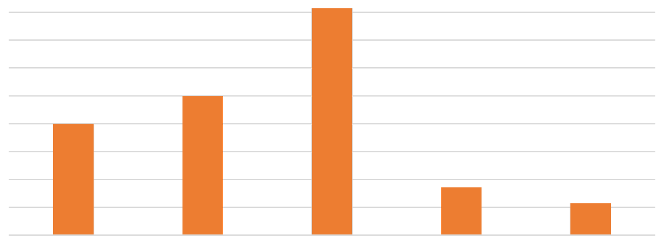

Fig 4.14
Level of satisfaction for the Foot wear & other accessories
45%
40%
35%
30%
25%
20%
15%
10%
5%
0%
40.72%
25%
20%
8.57%
5.71%
Excellent Very good Good Fair Average


Showing customers preferred location facilities
Table4.15

Response | Frequency | Percentage
Excellent | 30 54 47 8 | 21.43%
Very good | 1 140 | 38.57%
Good |  | 33.57%
Fair |  | 5.71%
Average |  | 0.72%
Total |  | 100%

Interpretation

From the fig 4.15 it can be seen that, 38.57% respondents preferred very good location facilities that encourage customers purchase in max fashion followed by, 33.57% good, 21.43% excellent, 5.71% fair and only 0.72% prefer average location facility.

Fig 4.15
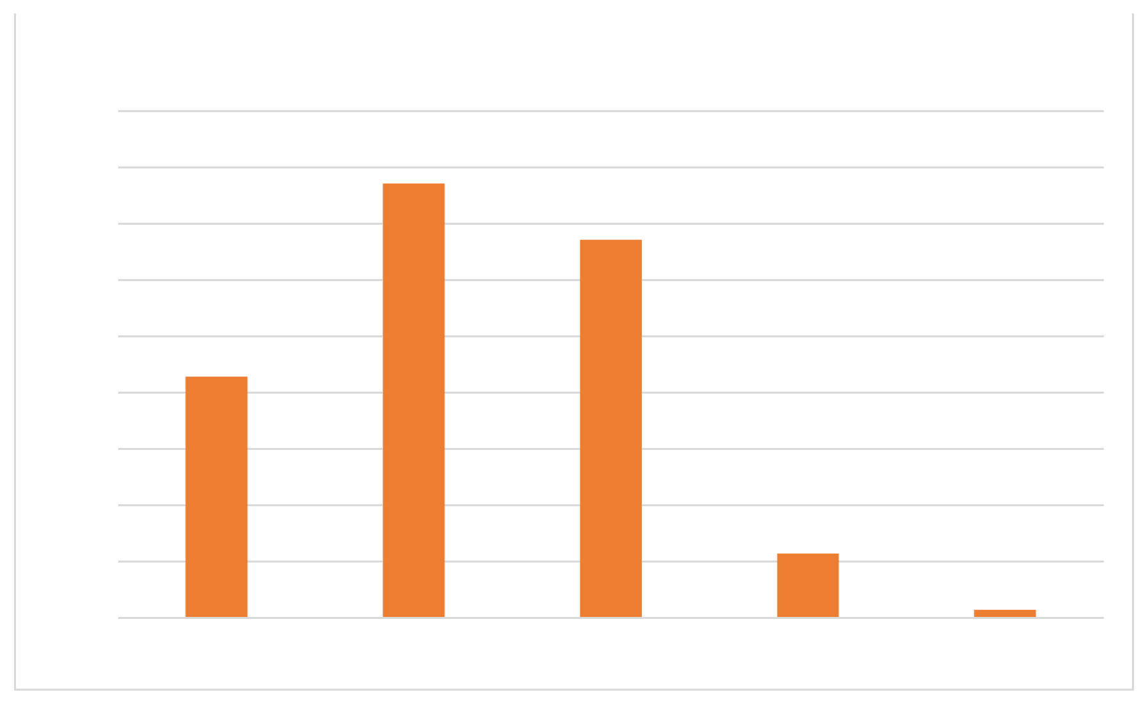
Customers preferred location facilities
45%
40%
35%
30%
25%
20%
15%
10%
5%
0%
38.57%
33.57%
21.43%
5.71%
0.72%
Excellent Very good Good Fair Average


Showing customers preferred price
Table4.16

Response | Frequency | Percentage
Excellent | 18 40 66 | 12.86%
Very good | 10 6 140 | 28.57%
Good |  | 47.14%
Fair |  | 7.14%
Average |  | 4.29%
Total |  | 100%

Interpretation

From the fig 4.16 it can be seen that, 47.14% respondents preferred good price that encourage customers purchase in max fashion followed by, 28.57% very good, 12.86% excellent, 7.14% fair and only 4.29% prefer average location facility.

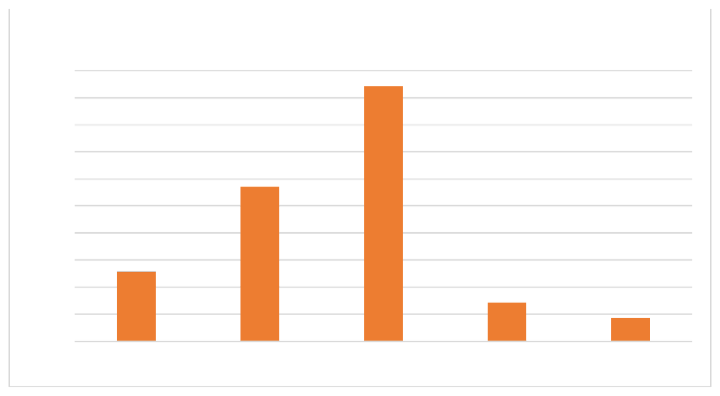
Fig 4.16
50%
45%
40%
35%
30%
25%
20%
15%
10%
5%
0%
Customers preferred price
47.14%
28.57%
12.86%
7.14%
4.29%
Excellent Very good Good Fair Average

Showing customers preferred quality of product

Table4.17

Response | Frequency | Percentage
Excellent | 29 52 48 9 | 20.71%
Very good | 2 140 | 37.14%
Good |  | 34.29%
Fair |  | 6.43%
Average |  | 1.43%
Total |  | 100%

Interpretation

From the fig 4.17 it can be seen that, 37.14% respondents preferred very good quality of product that encourage customers purchase in max fashion followed by, 34.29% good, 20.71% excellent, 6.43% fair and only 1.43% prefer average quality of product.

Fig 4.17
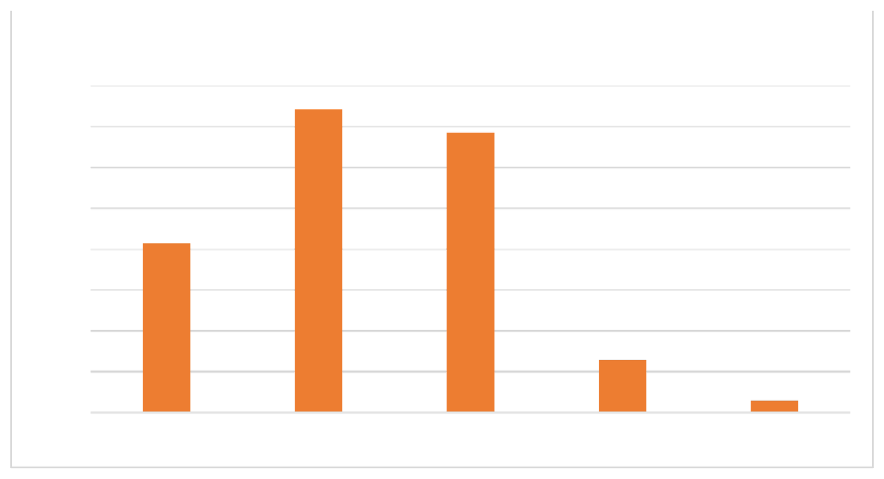
40%
35%
30%
25%
20%
15%
10%
5%
0%
Customers preferred quality of product
37.14%
34.29%
20.71%
6.43%
1.43%
Excellent Very good Good Fair Average

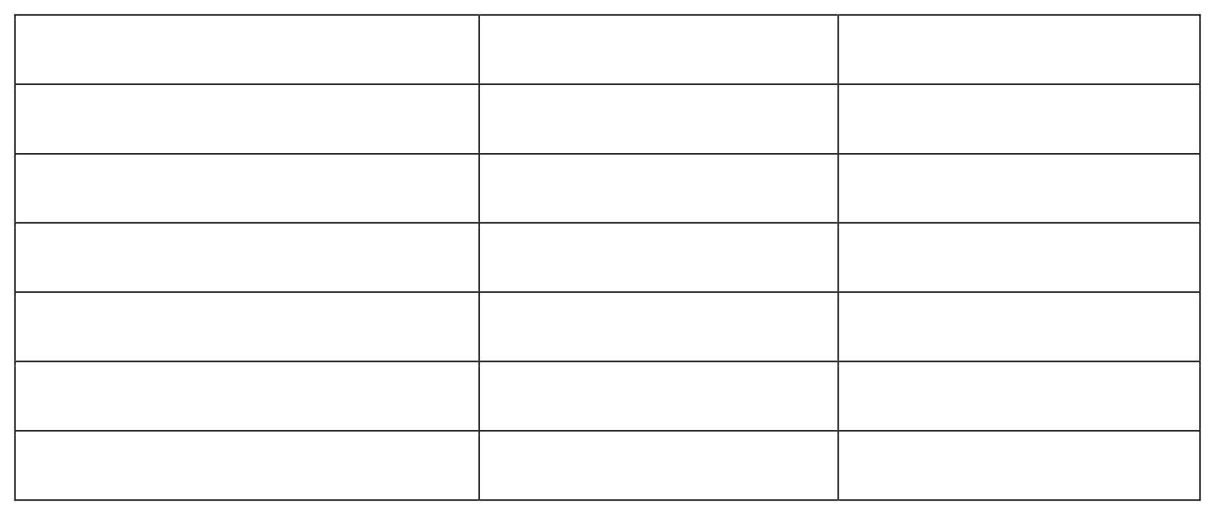
showing customers preferred staff service
Table4.18

Response | Frequency | Percentage
Excellent | 25 55 50 | 17.86%
Very good | 10 0 140 | 39.29%
Good |  | 35.71%
Fair |  | 7.14% 0%
Average |  | 100%
Total

Interpretation

From the fig 4.18 it can be seen that, 39.29% respondents preferred very good staff service that encourage customers purchase in max fashion followed by, 35.71% good, 17.86% excellent, 7.14% fair and 0% prefer average staff service.

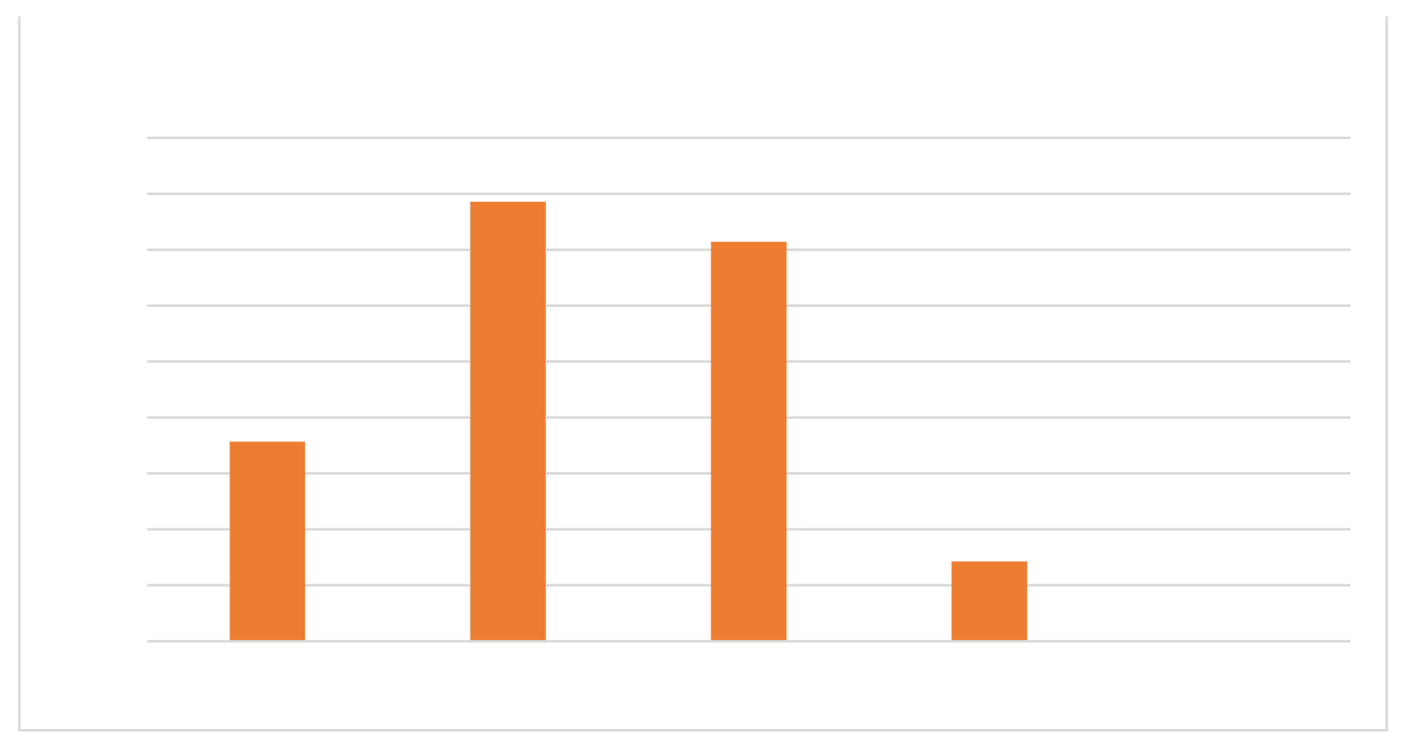
Fig 4.18 Chart
45%
40%
35%
30%
25%
20%
15%
10%
5%
0%
Customers preferred staff service
39.29%
35.71%
17.86%
7.14%
Excellent Very good Good Fair
0%
Average

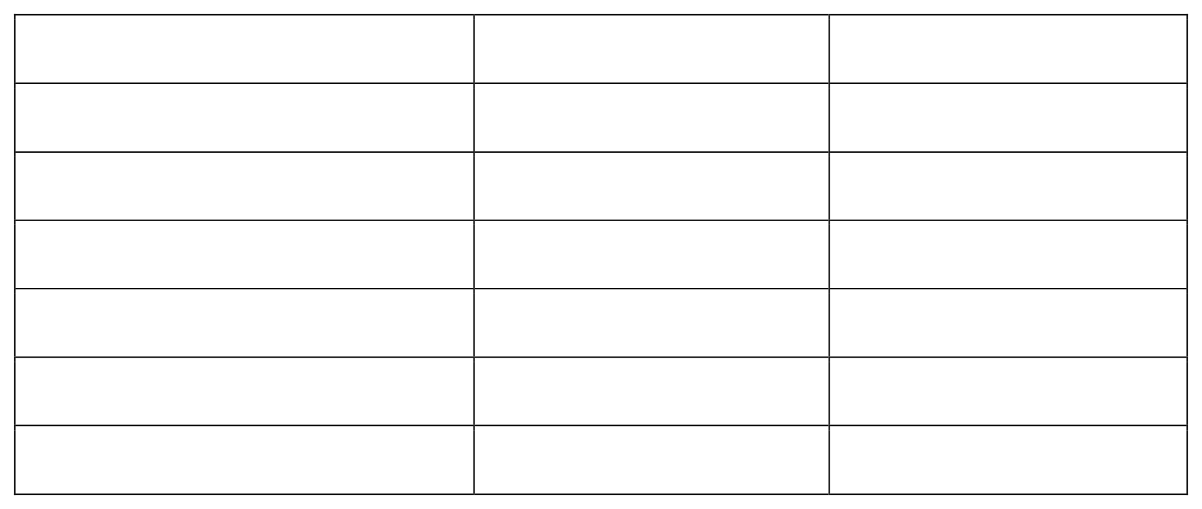
showing customers preferred variety/ range available
Table4.19

Response | Frequency | Percentage
Excellent | 22 47 54 | 15.71%
Very good | 11 6 140 | 33.57%
Good |  | 38.57%
Fair |  | 7.86%
Average |  | 4.29%
Total |  | 100%

Interpretation
From the fig 4.19 it can be seen that, 38.57% respondents preferred good variety/range
available that encourage customers purchase in max fashion followed by, 33.57% very good, 15.71% excellent, 7.86% fair and only 4.29% prefer average variety/range available.

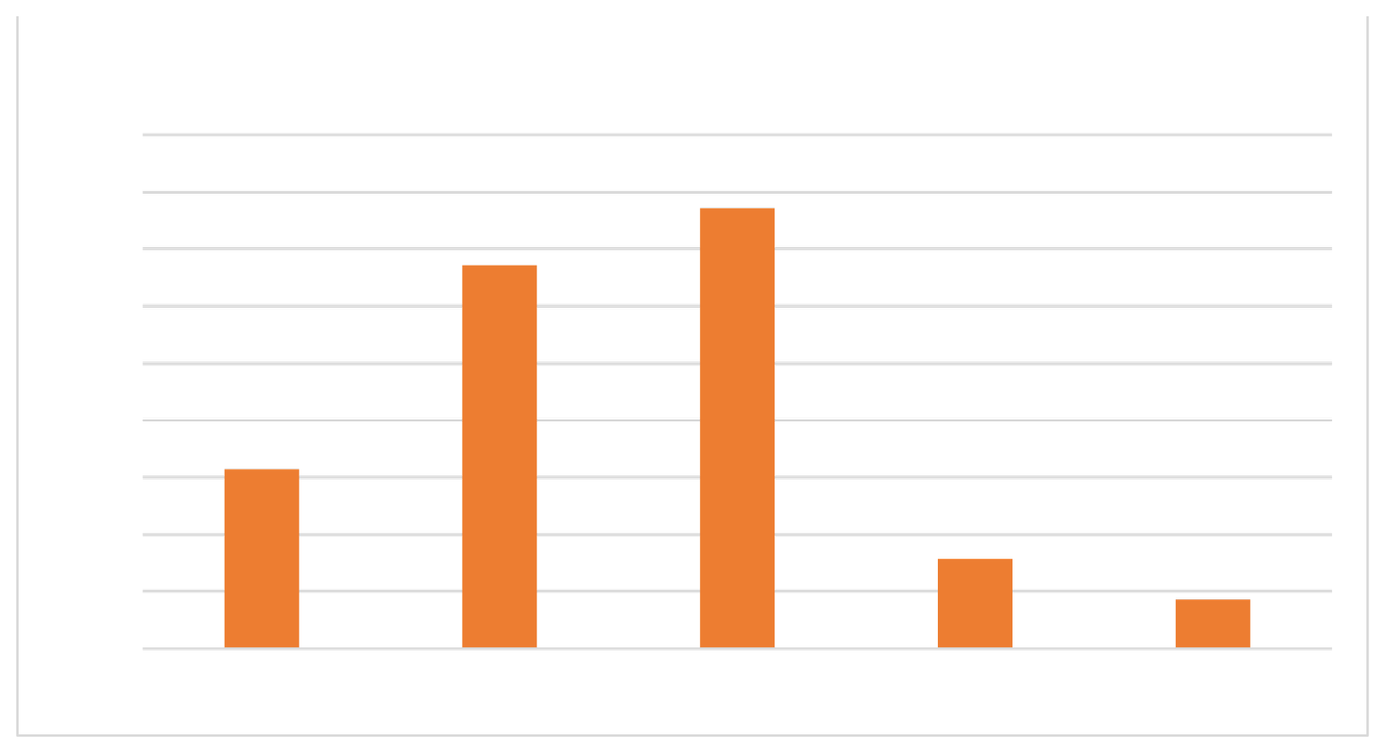
Fig 4.19
45%
40%
35%
30%
25%
20%
15%
10%
5%
0%
Customers preferred variety/ range available
38.57%
33.57%
15.71%
7.86%
4.29%
Excellent Very good Good Fair Average

Chart showing customers overall experience visiting at the max fashion store
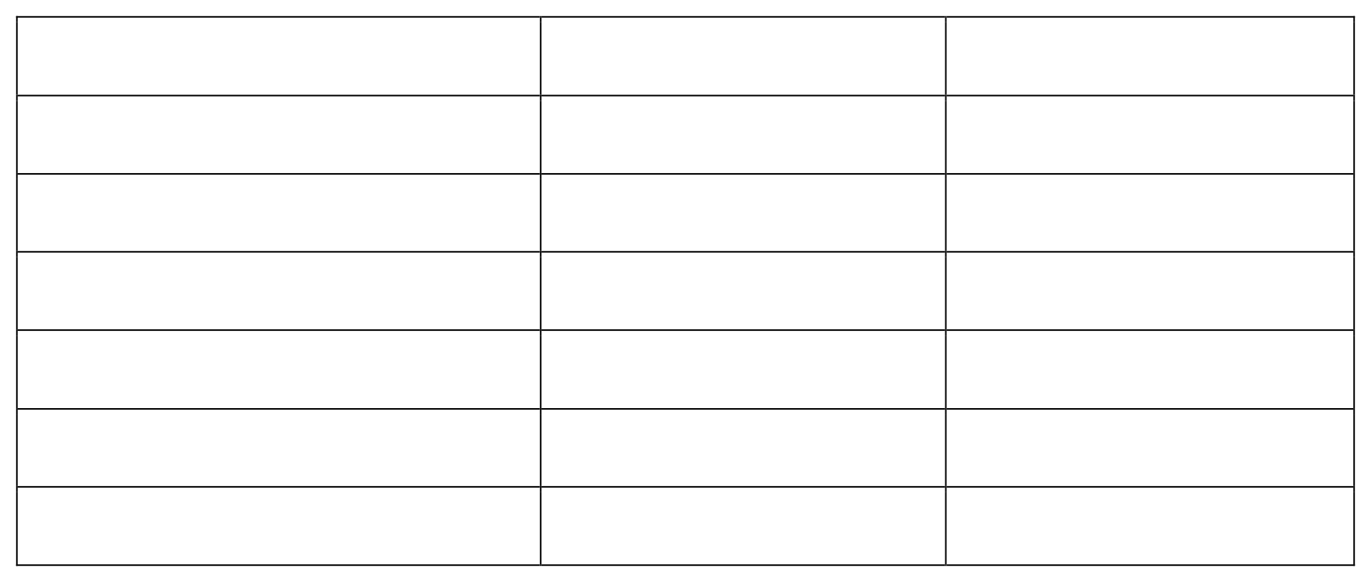
Table 4.20

Response | Frequency | Percentage
Excellent | 34 83 23 0 | 24.28%
Good | 0 140 | 59.29%
Average |  | 16.43% 0%
Bad |  | 0% 100%
Worst
Total

Interpretation
From the fig 4.20 it can be seen that, 59.29% of the respondents have good experience at visiting the max fashion store followed by, 24.28% excellent and 16.43% average. 0% of respondents have bad and worst experience at visiting the store.

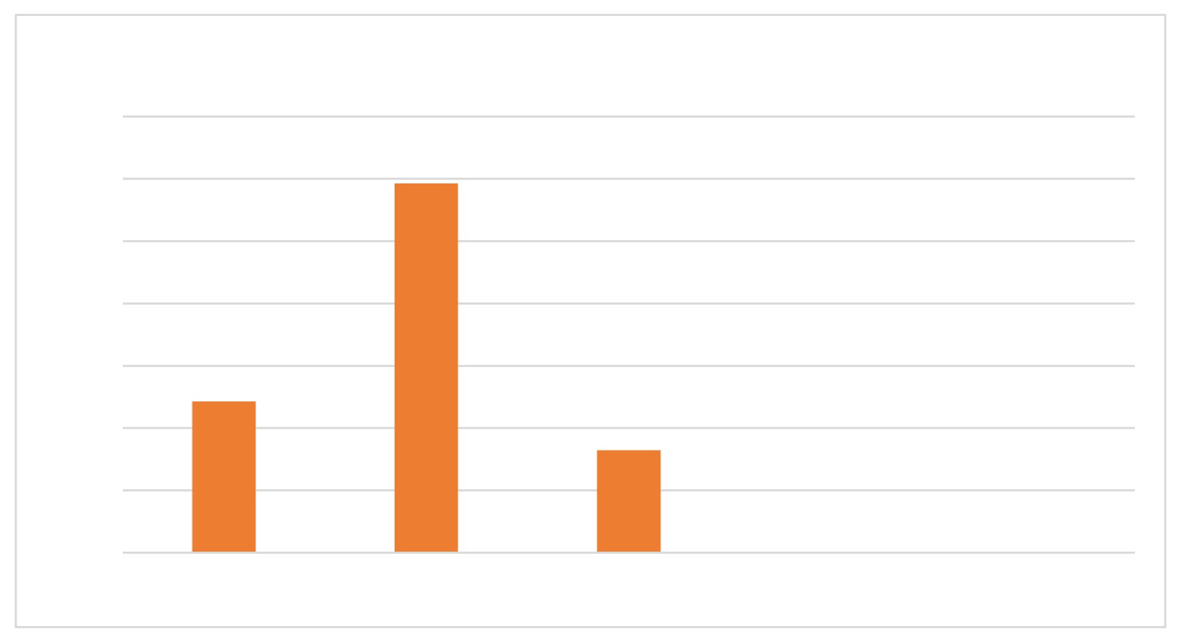
Fig 4.20
Customers overall experience visiting the store
70%
16.43%
Average
0%
Bad
0%
Worst

60% |  | 59.29%
50%
40%
30% | 24.28%
20%
10%
0% | Excellent | Good

Showing customers face any obstacles while engaging with max fashion

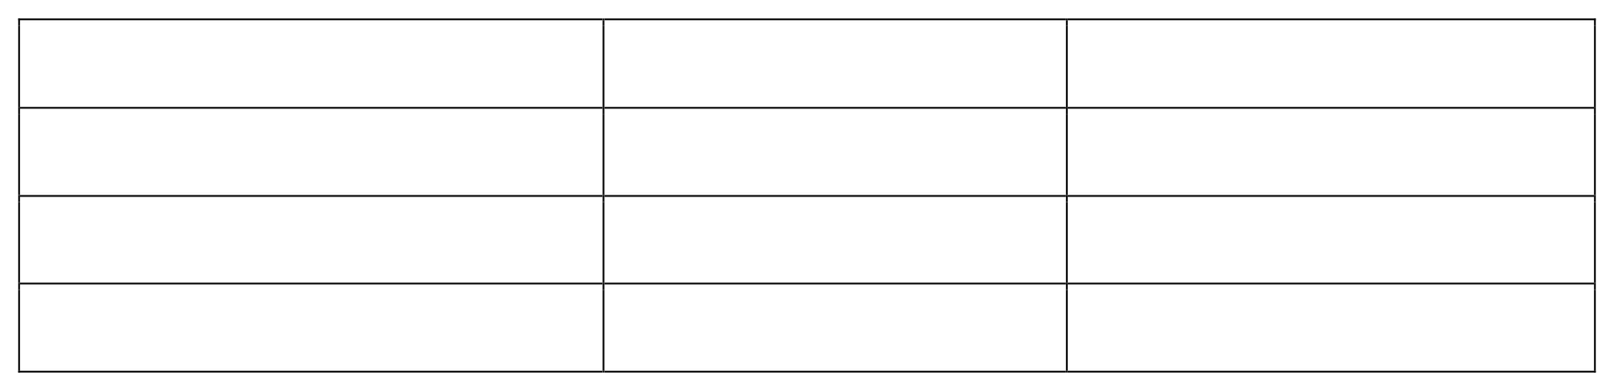
Table 4.21

Response | Frequency | Percentage
Yes | 13 127 140 | 9.29%
No |  | 90.71%
Total |  | 100%

Interpretation

From the fig 4.21 it can be seen that, 9.29% respondents face obstacles from max fashion while other 90.71% respondents didn’t face any obstacles. The obstacles faced by the
customers while engaging with max fashion is that they need to improve quality of clothes. According to customers, max clothes do not last long and tend to fade, customers found very limited stocks in max. They have a suggestion to increase the number of outfits. Other
obstacle faced by customer is that max products are charged with high price and the offer
products cannot be re-exchanged, few online products does not available in the store, Parking facility could be made better.

Fig 4.21
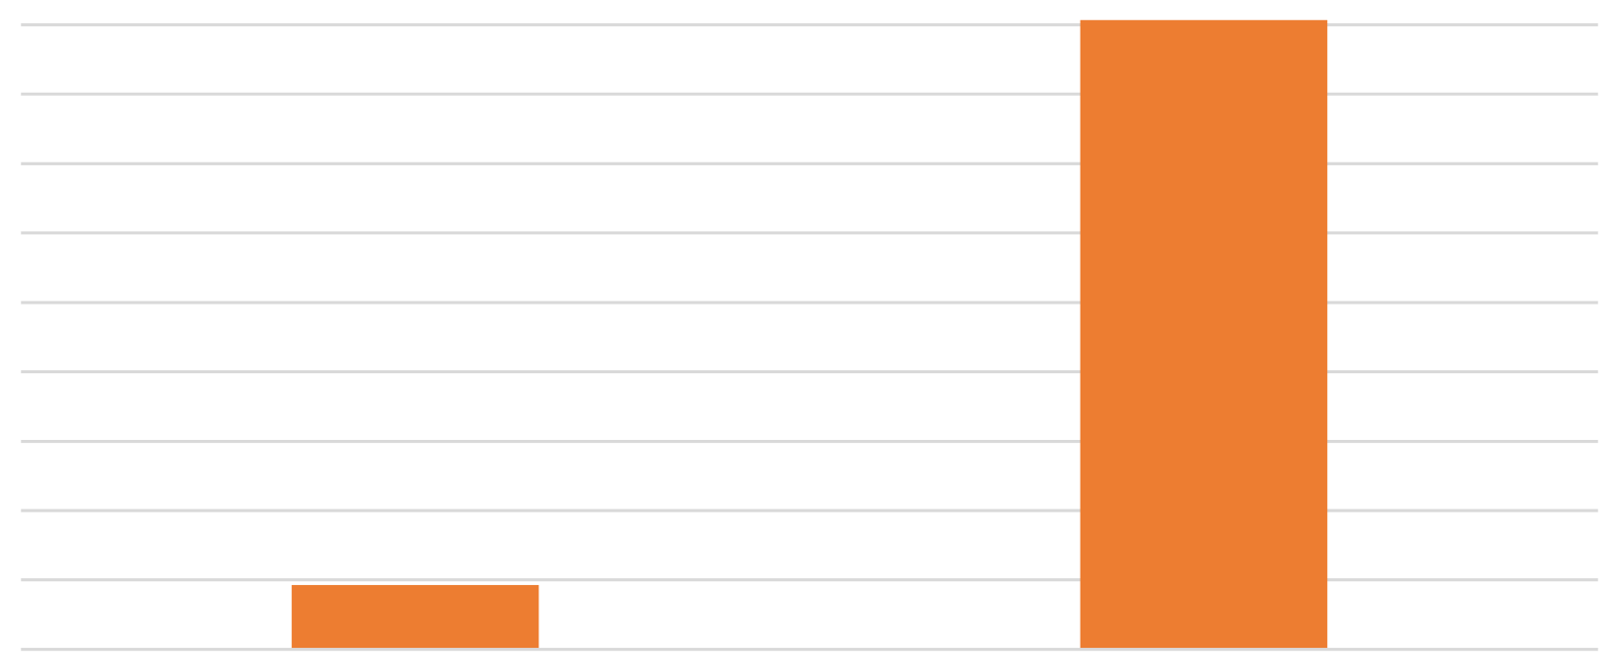

100%
90%
80%
70%
60%
50%
40%
30%
20%
10%
0%
Customers face any obstacles while engaging with max fashion
90.71%
9.29%
Yes No

CHAPTER-5

Summary of Findings
Thefollowing details canbeinferredafteranalysis with a sample size of 140, by questionnaire method to find out the customer satisfaction towards the Max fashion brand.
s
    - Majority of the respondents are female that is 56.43% and 42.86% of respondents are male.
    - The study reveals that nearly 67.14% of the respondents are between 18-24 years, 24.29% are 25-35 years and only 8.57% of the respondents are above 35
years.
    - Majority of respondents (57.86%) frequency of the purchase in seasonally/ during offers in occasion and 25% of respondents in quarterly.
    - Majority of respondents (49.29%) influenced to buy from max fashion through reference group like friends & family members and 35% are through store displays.
    - Majority of respondents (65.71%) are satisfied with the customer assistance process in max fashion shopping and (0%) never dissatisfied with the customer assistance process.
Majority of respondents (94.29%) are satisfied with the billing system process of max fashion
    - ​
store and (5.71%) never satisfied with the billing system process.
Majority of respondents (78.57%) except the discount/ attractive offers as their promotional
    - services from the max fashion store, 15.71% expect through coupons. 5.71% through free gifts and never (0%) of respondents expect game shows from max fashion.

    - Majority of the respondents (37.86%) are checking Max Buddy program most of the time and 27.14% never checking the program.
    - Majority of respondents (33.57%) sometimes get promotional coupons for future purchase through max store, only 9.29% get always and 18.57% never get any promotional coupons for
their future purchase.
    - Majority of respondents (32.14%) never redeemed the promotional coupons in the max fashion store, 20.71% sometimes redeemed it, whereas 12.14% of customers always redeemed the promotional coupons.

    - Majority of respondents (39.28%) have good level of satisfaction for the Mens wear offered by the max store, 39.29% of respondents felt very good level of satisfaction for the Womens wear, 38.57% felt good level of satisfaction for the kids wear and 40.72% have good level of satisfaction for the foot wear & other accessories.

    - Majority of respondents (38.57%) rank very good location facilities that encourage customers purchase in max fashion, 47.14% rank good for the reasonable price offered by max store, 37.14% respondents rank very good for the quality of product, 39.29% respondents preferred very good staff service and 38.57% respondents rank good variety/range available in the store.
    - Majority of respondents (59.29%) have good experience at visiting the max fashion store and never (0%) of respondents have bad and worst experience at visiting the store.
    - Majority of respondents (9.29%) face obstacles from max fashion while other 90.71% respondents never face any obstacles.
    - The obstacles faced by the customers while engaging with max fashion is that they need to improve quality of clothes. According to customers, max clothes do not last long and tend to
fade, customers found very limited stocks in max. Majority of respondents have a suggestion to
    - increase the number of outfits.
    - Obstacle faced by customer is that max products are charged with high price and the offer products cannot be re-exchanged, few online products does not available in the store Majority of
    - the respondents have an opinion that the external appearance of the products should be improved.
    - Most of the respondents have an opinion that the company maintains better customer relationship.

CONCLUSION
.According to the case company of max brand, we can conclude some suggestions for enterprise how to improve its customer satisfaction. To start with, quality is the core aspect that every enterprise should pay attention to it. If the company loses the quality, it will lose the basic competitiveness and customer trust. Hence, it requires company improve its quality inspection system, regularly conduct thorough inspection for the sampled production. So, no matter what customer need, the employees must try their best to help customers and solve customers' problem.

Max is offering good services of customer’s preference, which is reflected on the customer. Majority of customers are satisfied with the max products with better services. Max managed to satisfy its customers by providing quality products at best price. Customer is the king in the market to satisfy a customer is the most difficult task in the business, if the businesses don’t have the customers, it will start struggling for its survival. MAX has gained its trust among the valuable customers by providing quality products at best price

REFERANCE
Alvesson. M (2012), The Swedish Economy, Swedbank, Vol.22, No.6, pp1-3 Anderson, E. W, Sullivan. W. M (1993).
The Antecedents and Consequences of Customer Satisfaction for Firms, Marketing Science, Vol.12, No.2, pp125-143.
Amaratunga. D, Baldry. D, Sarshar. M, Newton. R (2002). Quantitative and qualitative research in the built environment: application of "mixed'' research approach, Work Study, Vol.51, No.1, pp17-31
Bagozzi. P. R, Rose. A. J, Celly. S. K, Coronel. F (1998). Marketing Management, USA, Prentice Hall
Bäckstörm.C, Bauer. M (2012). Swedish Fashion Companies - an analysis of international expansion strategies, Unpublished bachelor thesis, University of Gothenburg, pp1-60
Bolton. R. N, Drew. H. J (1991). A Multistage Model of Customers Assessments of Service Quality, Journal of Customer Research, Vol.17, No.4, pp375-385
Bergamn. B, Klefsjö. B (2003). Quality from customer needs to customer satisfaction, Poland, Pozkal
Bradley. F (1991). International marketing strategy, Prentice Hall International, UK

Brooksbank. R (1994), The Anatomy of Marketing Positioning Strategy, Marketing Intelligence & Planning, Vol.12, No.4, pp10-14
Carriban. M (2012). Salary & Employment Insights 2012, China, Hudson

